**OPEN LAB END SEMESTER PROJECT**

**ONLINE LIBRARY MANAGEMENT SYSTEM**

**R.ARIVANANDAM**

**CB.SC.I5DAS21114**

**Tools Used** :

* **IDLE Version**: Apache NetBeans 18
* **Java Version**: JDK 22
* **Database Connector**: PostgreSQL JDBC Driver 42.2.19
* **Database Management Tool**: pgAdmin 4

**Project Description**:  
The Online Library Management System is a Java web application for efficient library operations, management of books, and the administration of staff along with transaction tracking. Built with JDBC (Java Database Connectivity), this system connects to a PostgreSQL database to securely handle book records, staff details, and issued books. This project aims to simplify the tasks of the library by providing an organized and user-friendly platform for the management of books, staff, and book lending records.  
  
**Key Features**:  
1)Add, update, remove,and display book information to enable acomprehensive catalog of all books in the library.  
2) Ability to manage staff information-adding, updating, deletion, and display of the staff record to enhance management and control.  
3)Record the issue books to the members; makes the detailed data of issue and return date of each issued book  
4)User Authentication: It has login to ensure safe use of the system only to authorized users.  
5)Database Integration using PostgreSQL is used with JDBC in order to store data and perform CRUD operations securely, efficiently.

**Login.jsp:** This page facilitates user login to the library system. It includes input fields for username and password. Upon submission, it validates the credentials against the database and grants access to the user if the details are correct.

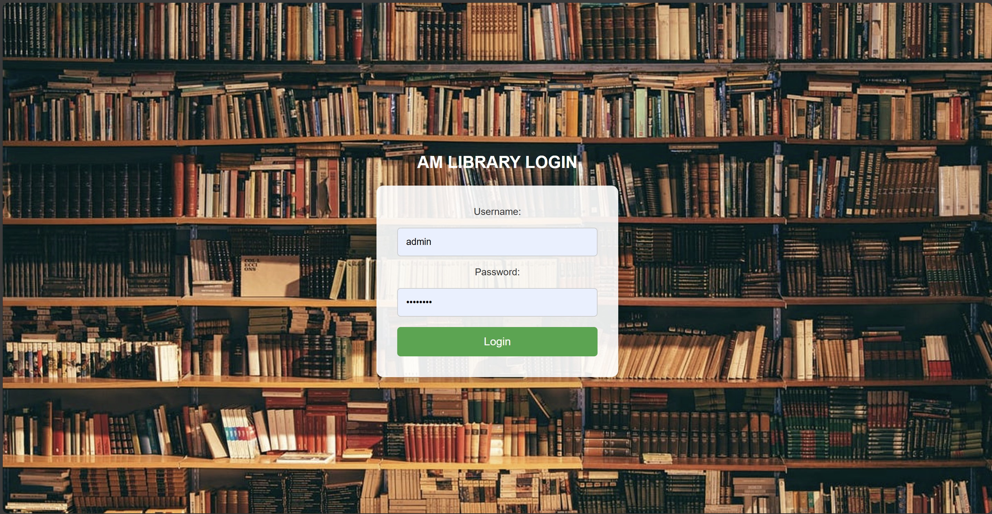

**Index.html:** This HTML page serves as the homepage for the library management system. It typically contains links to various features of the application, providing users with an overview and easy access to different sections of the system.

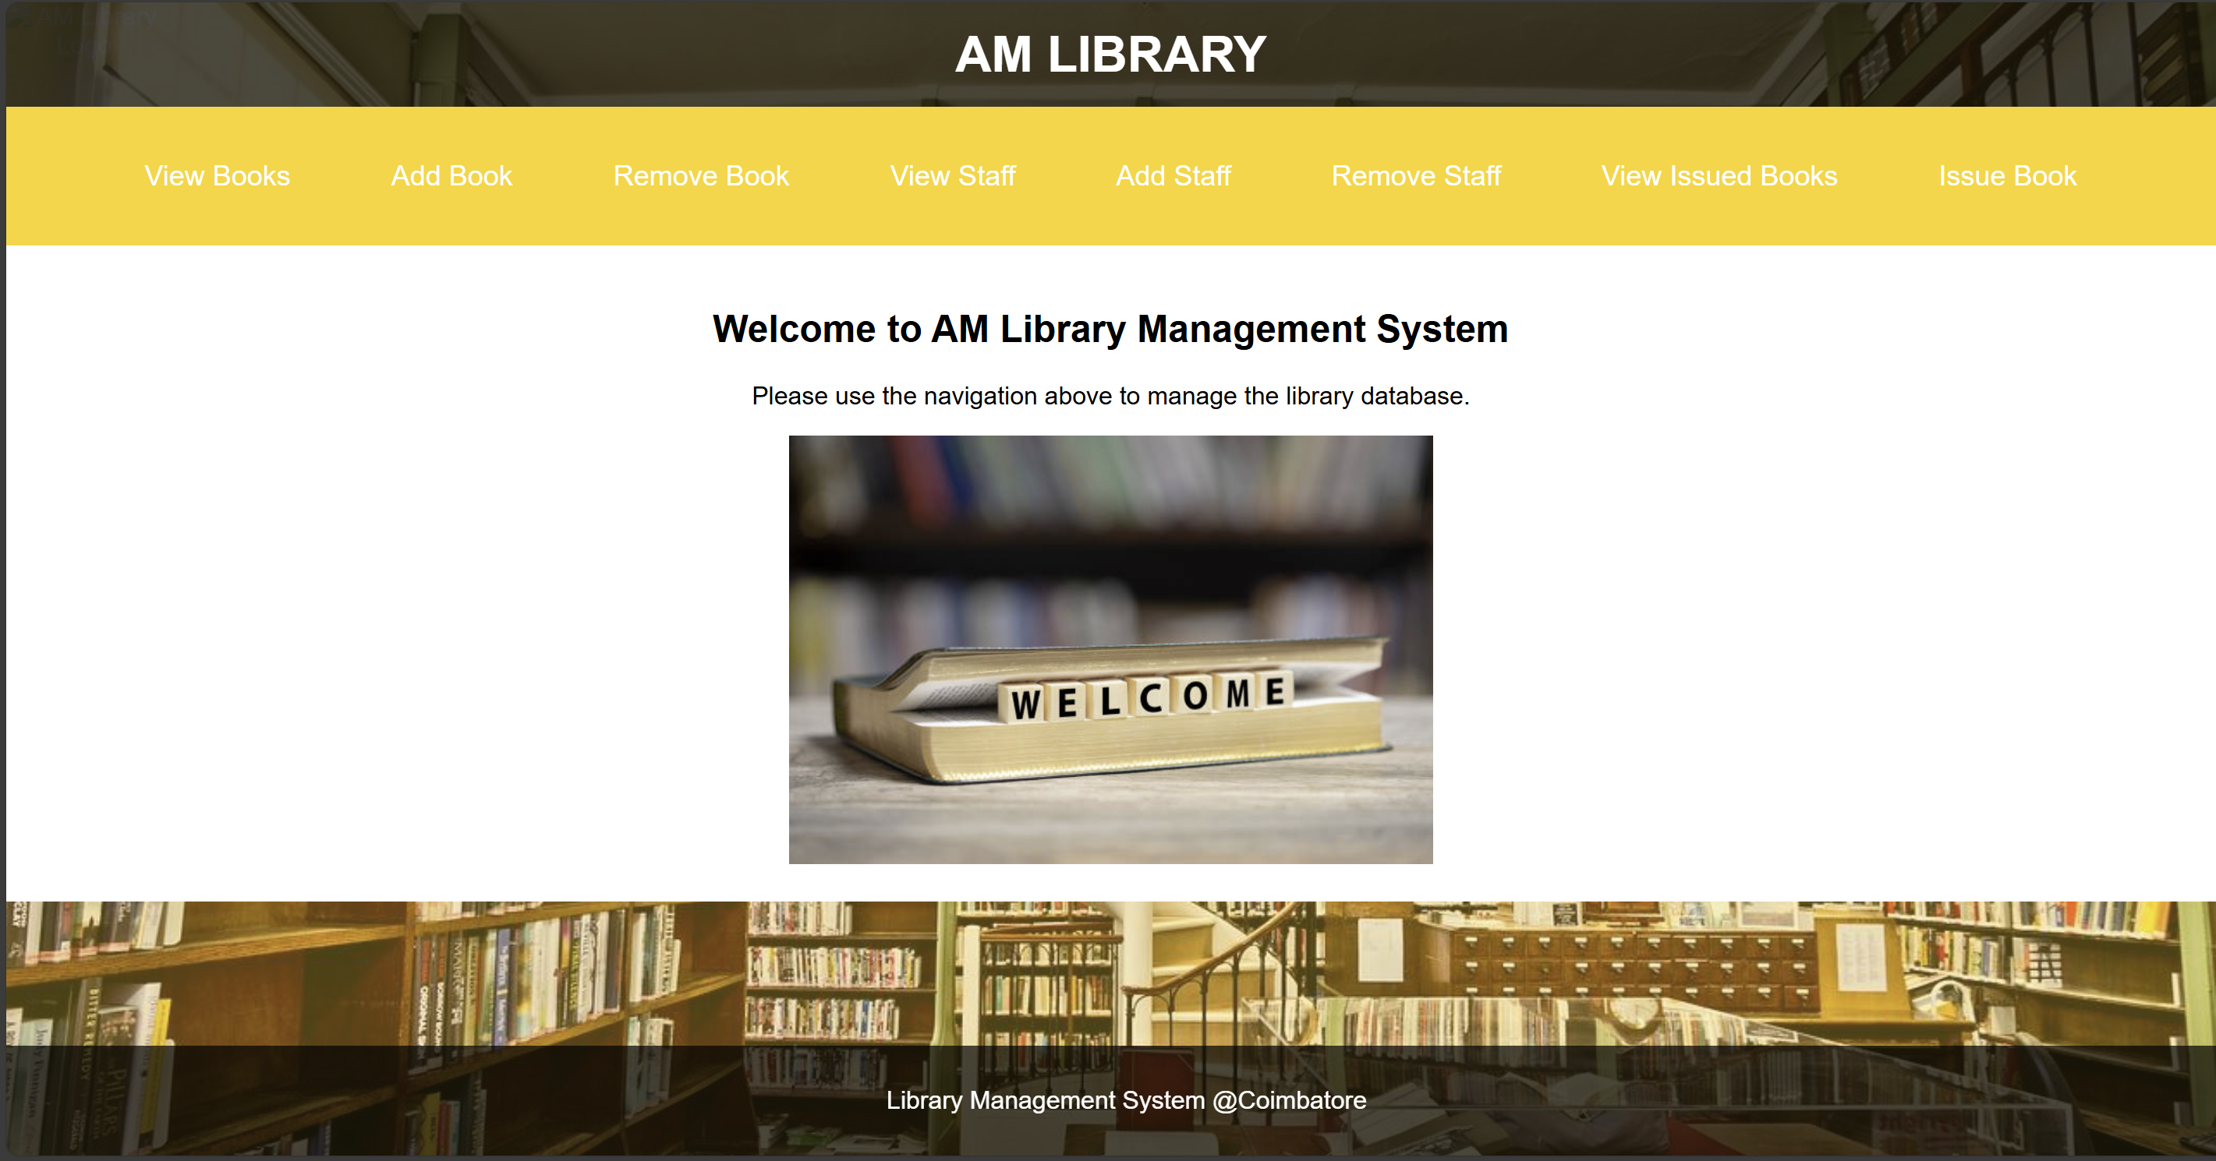

**viewBooks.jsp:** This page displays a list of all books available in the library. It presents a table that includes the Book ID, Name, Author, Category, and Number of Copies for each book. Users can easily navigate to options for adding or removing books through the provided links.

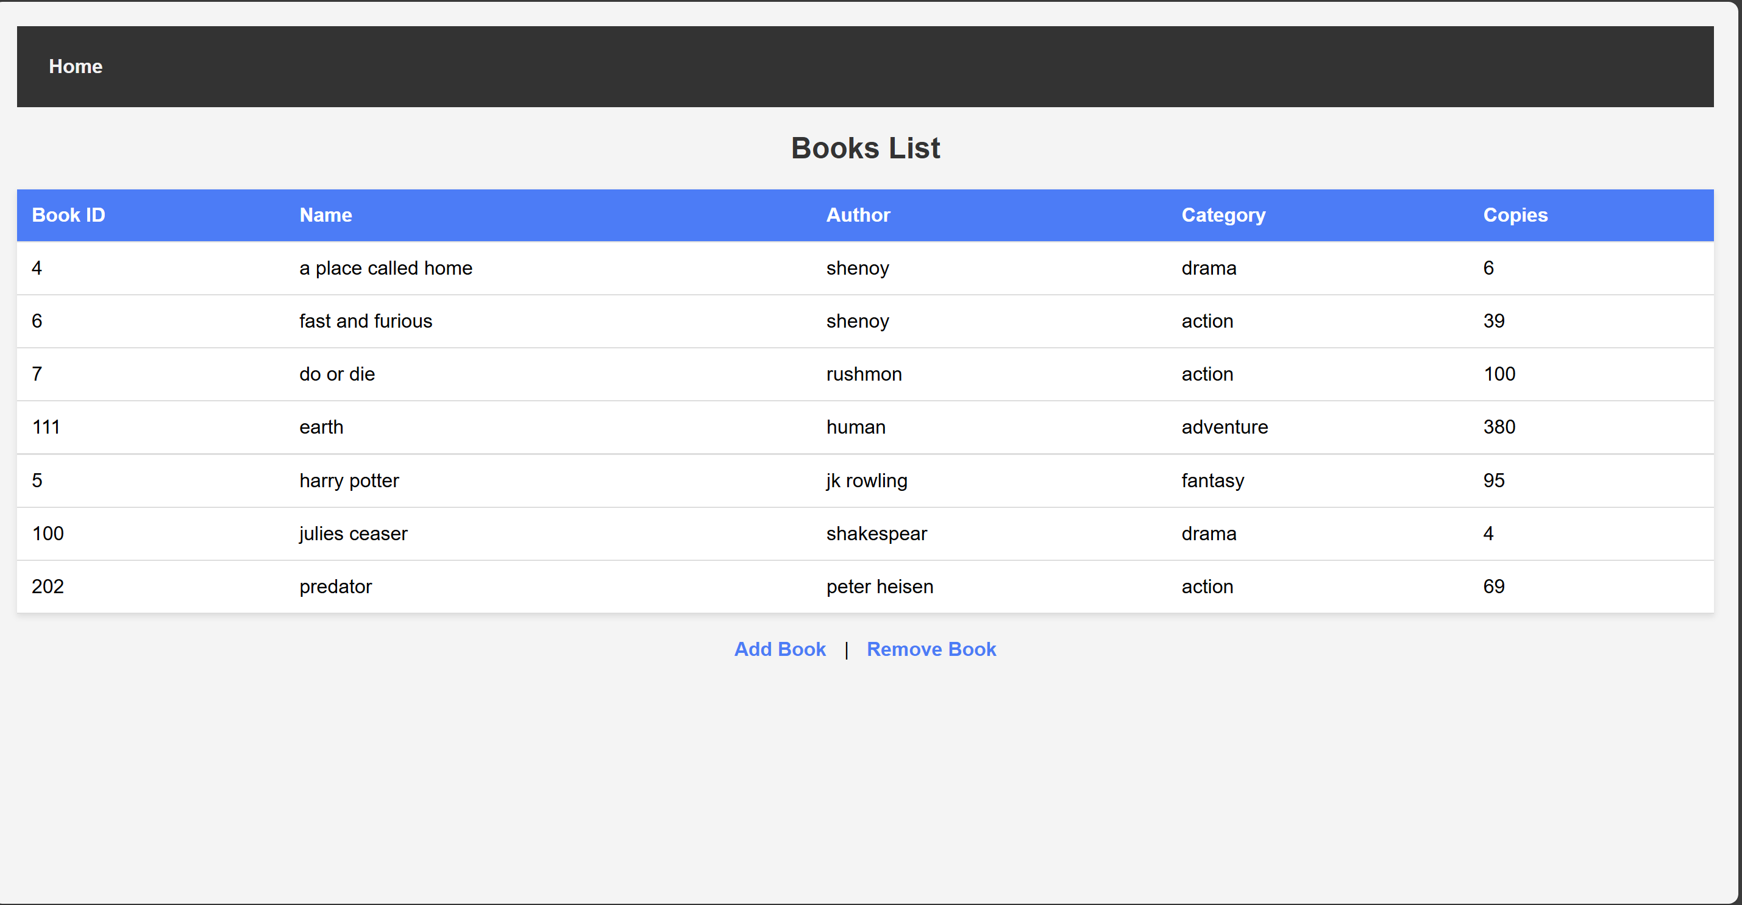

**addBook.jsp:** This page provides a form for adding new books to the library database. It includes input fields for details like Book ID, Name, Author, Category, and Number of Copies. Once submitted, the form sends data to create a new entry in the books database.

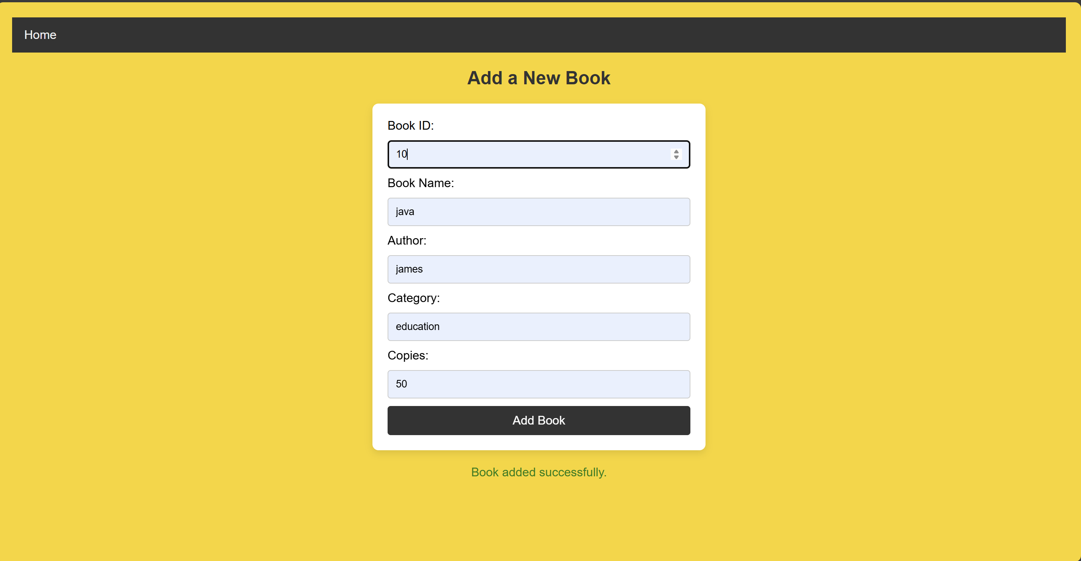

Change reflected by adding book in ViewBooks.jsp

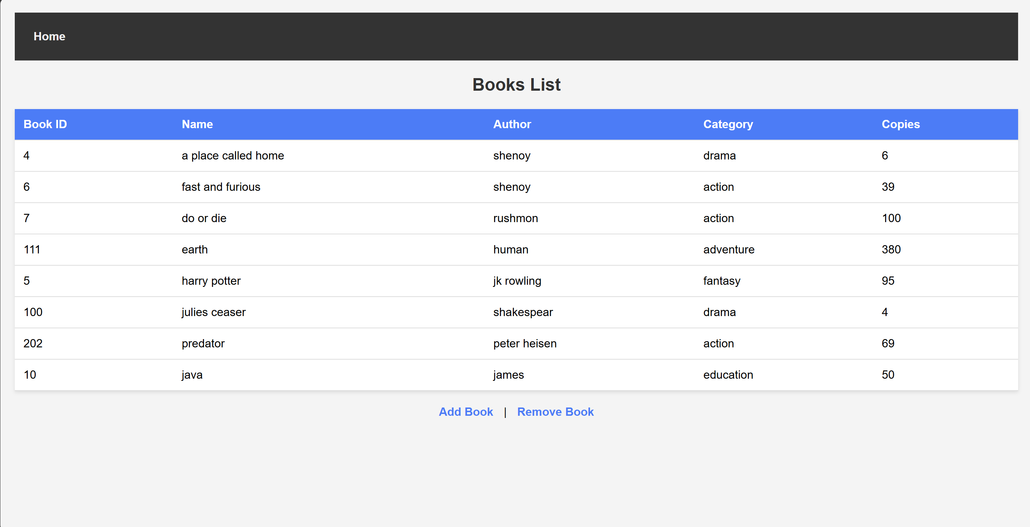

Change reflected in table books:

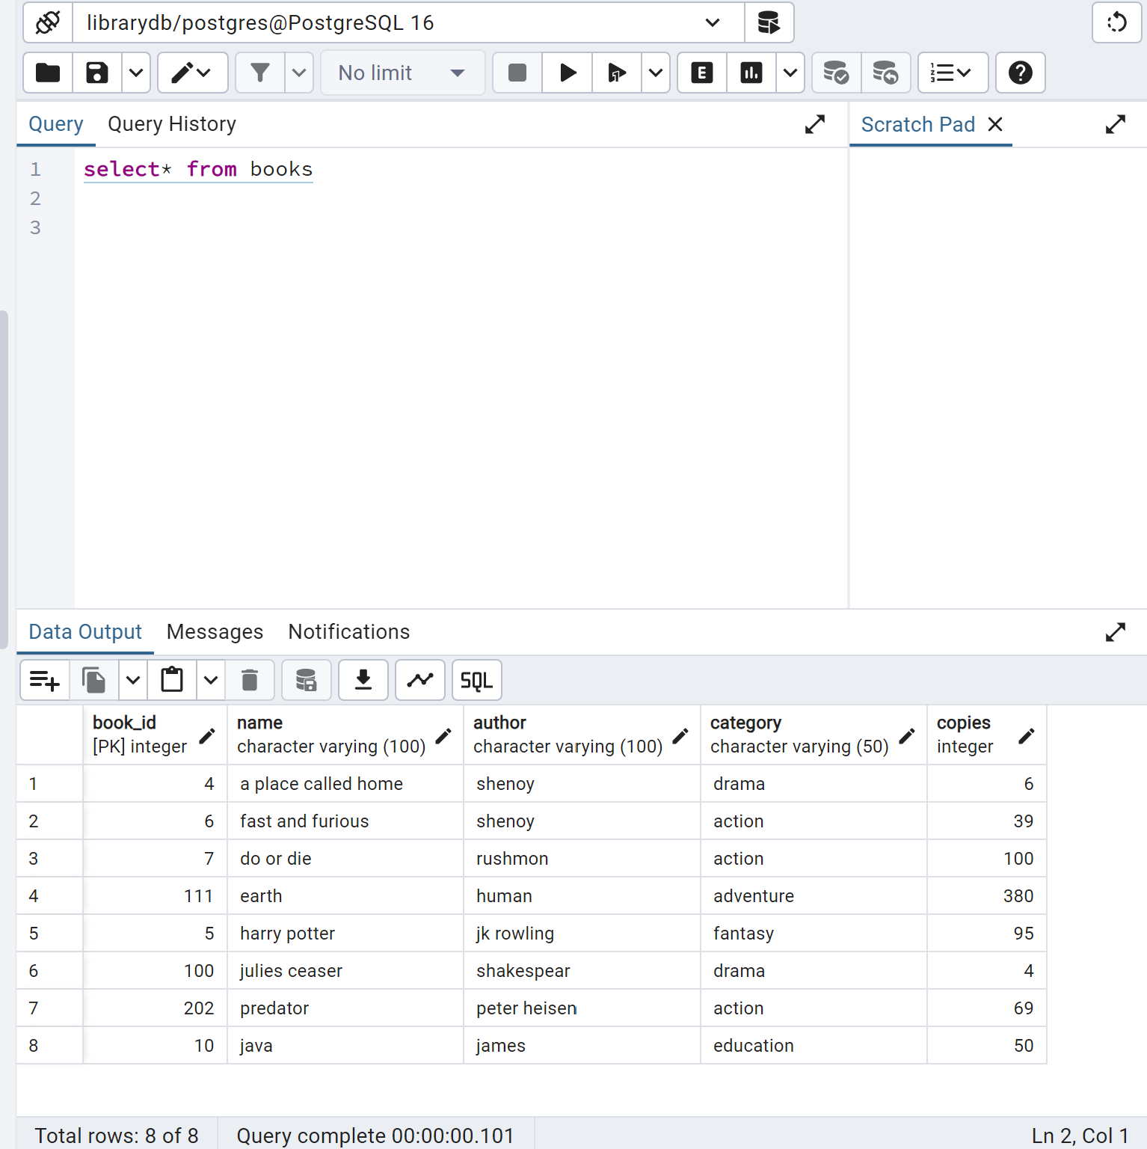

**removeBook.jsp:** This page allows users to remove existing books from the library. It typically presents a selection mechanism (like a dropdown or a table) for choosing which book to delete. Upon submission, the selected book is removed from the database.

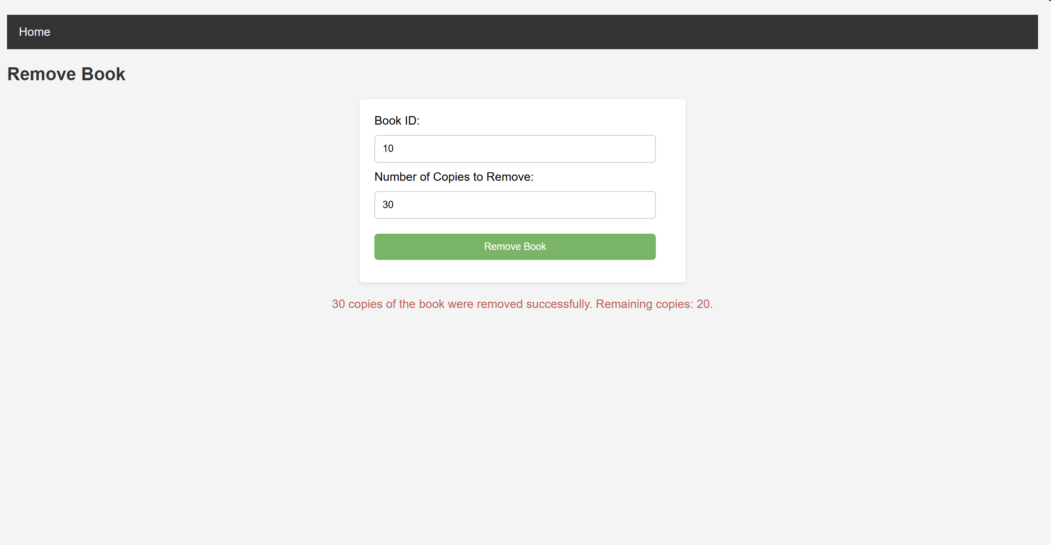

Change reflected in viewBooks.jsp

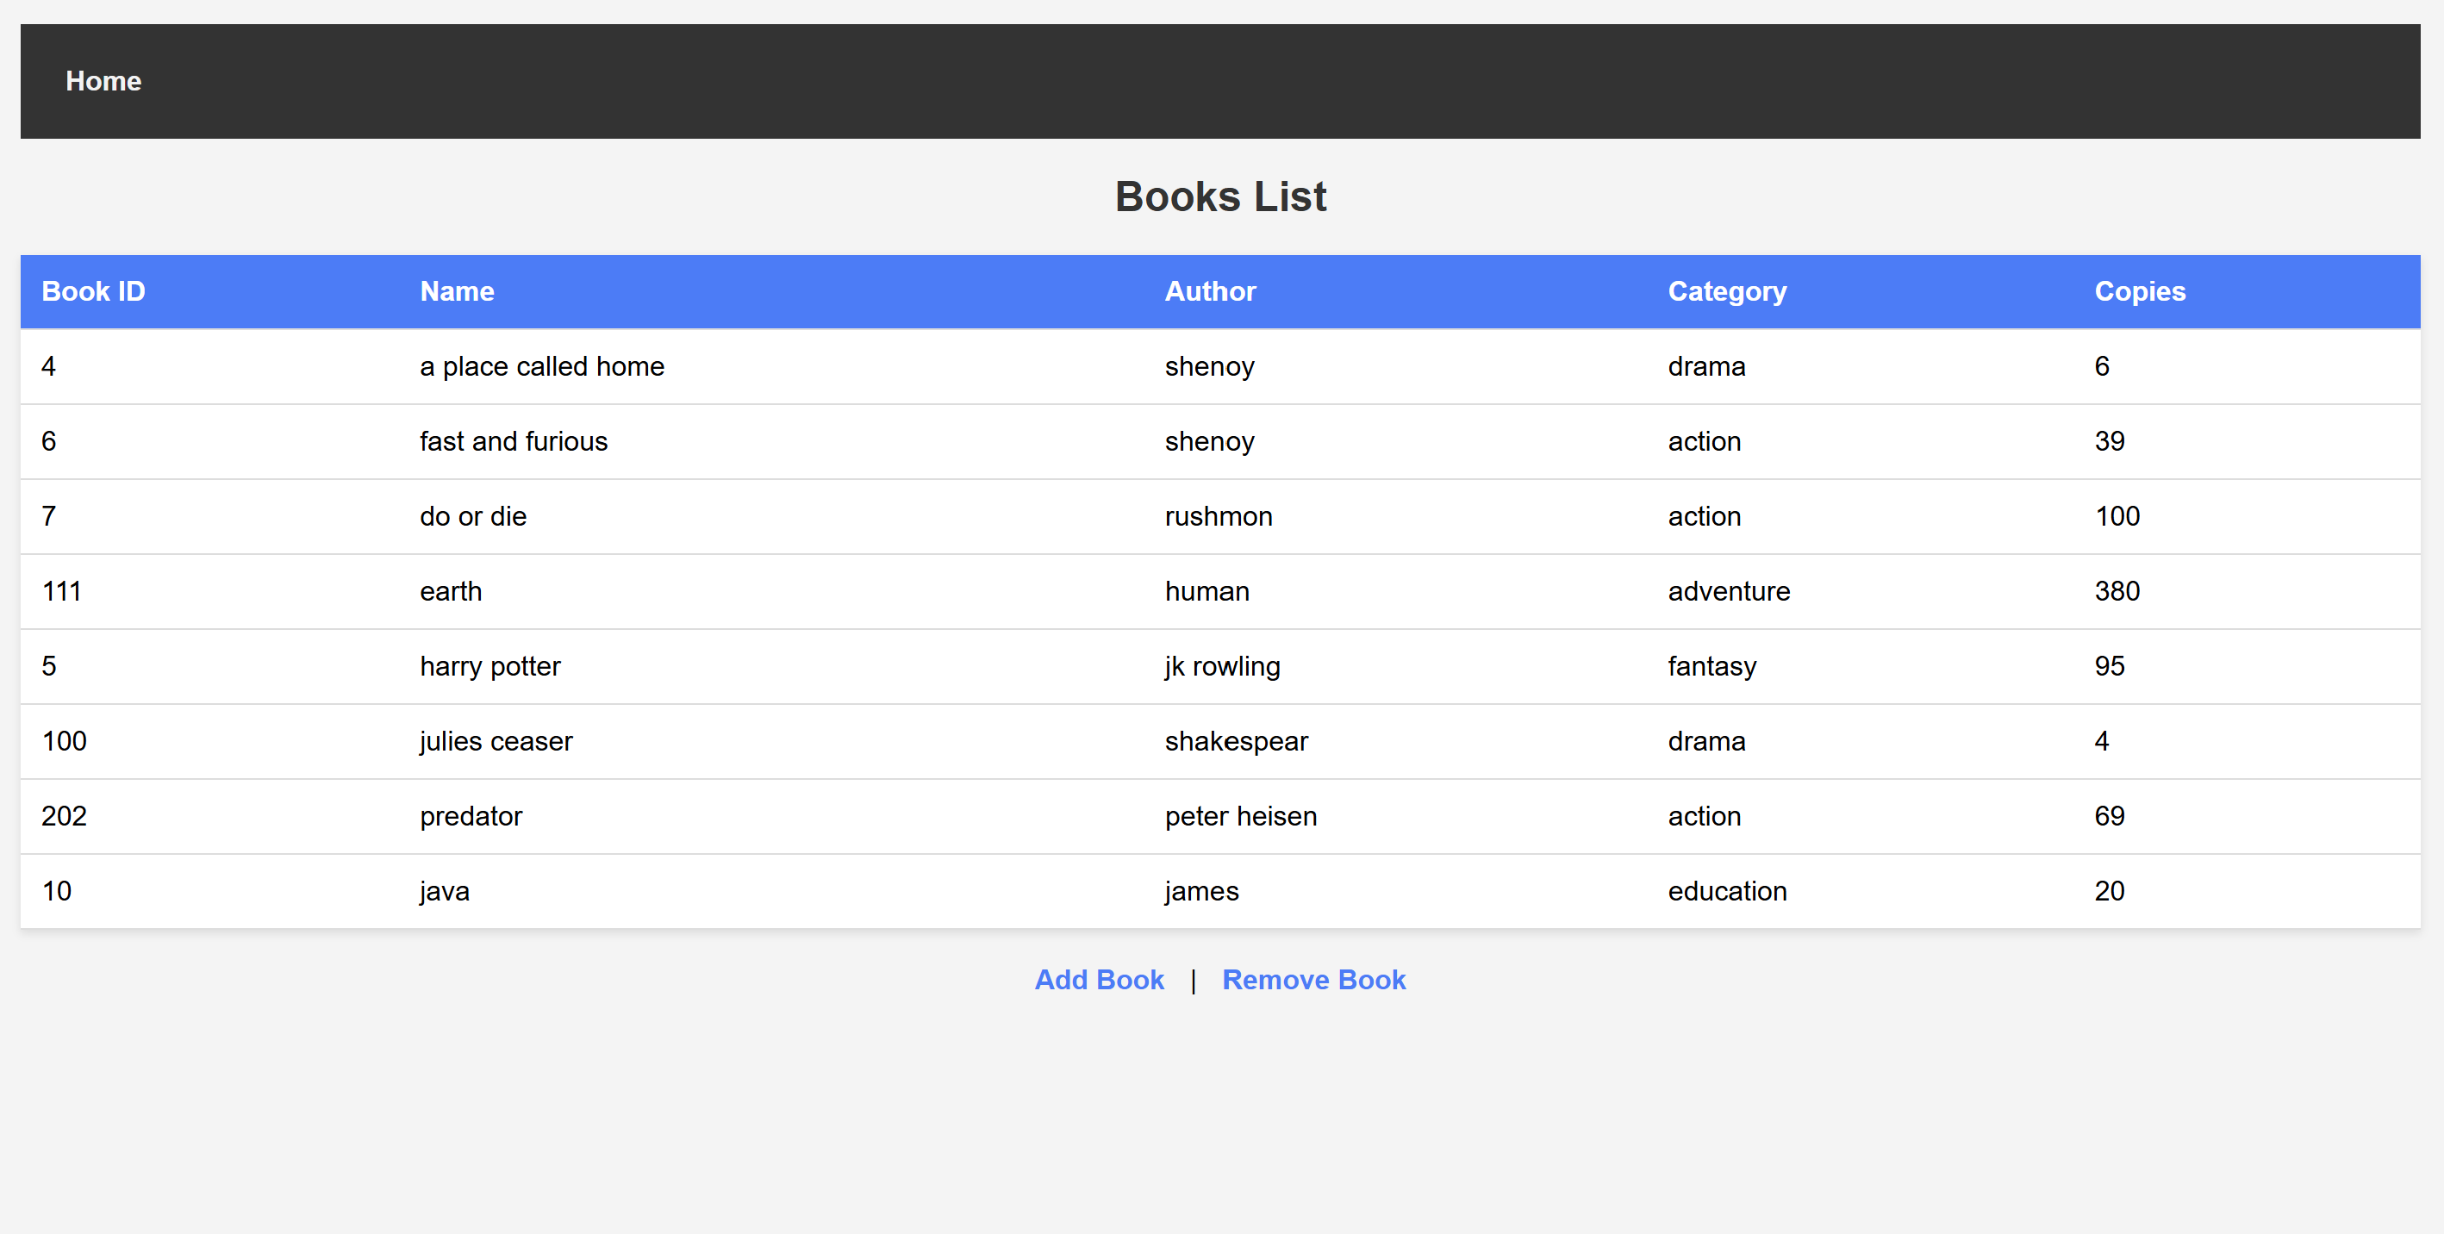

Change reflected in books table

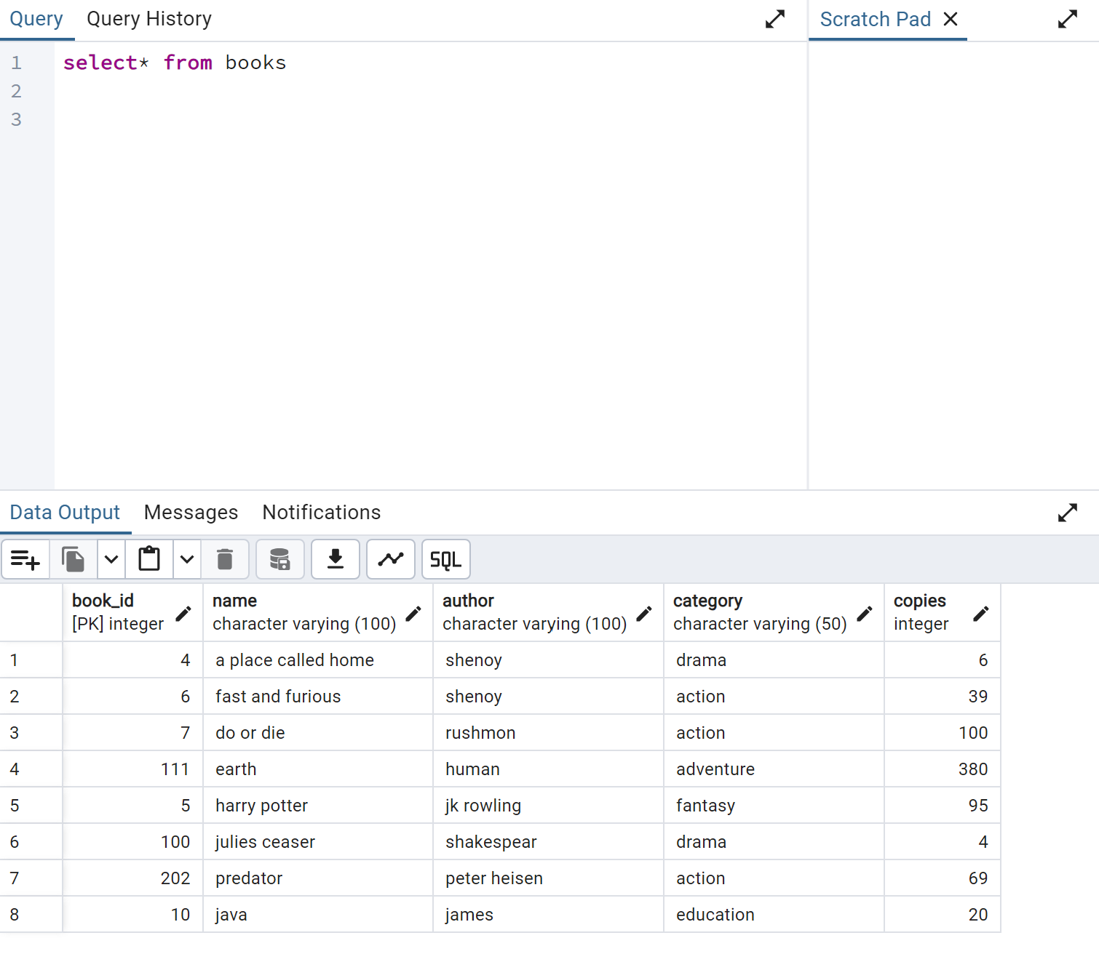

**viewStaff.jsp:** This page lists all administrators in the system. It displays a table containing the Admin ID and Name for each admin. Users can navigate to add or remove admins using the provided links, enabling easy management of administrative accounts.

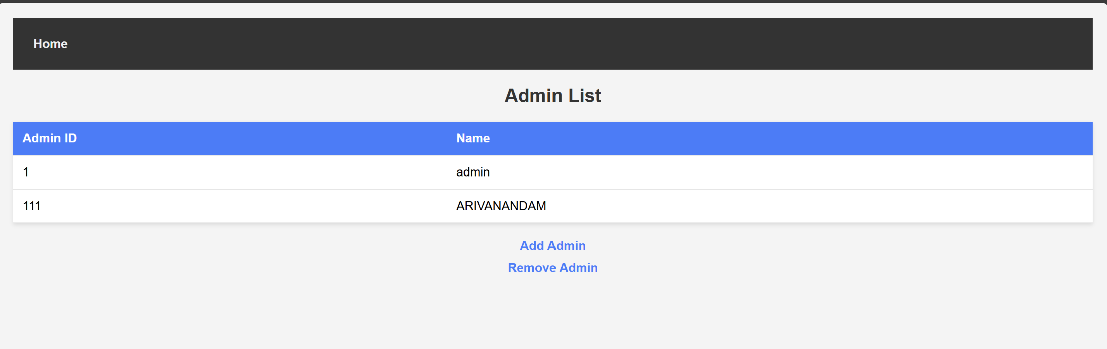

**addStaff.jsp:** This page provides a form for creating new admin accounts. It includes input fields for the Admin Name and other necessary details. Upon submission, the data is sent to the database to create a new admin record.

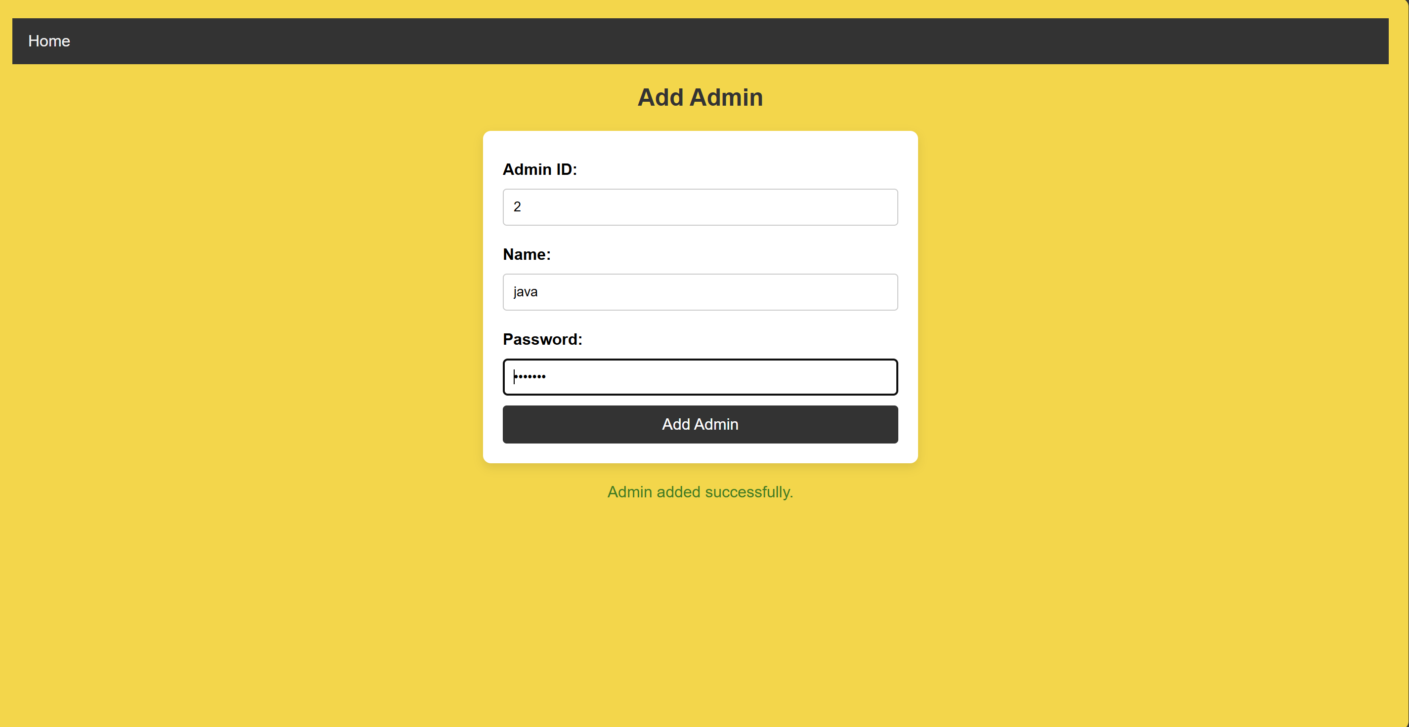

Change reflected in viewStaff.jsp

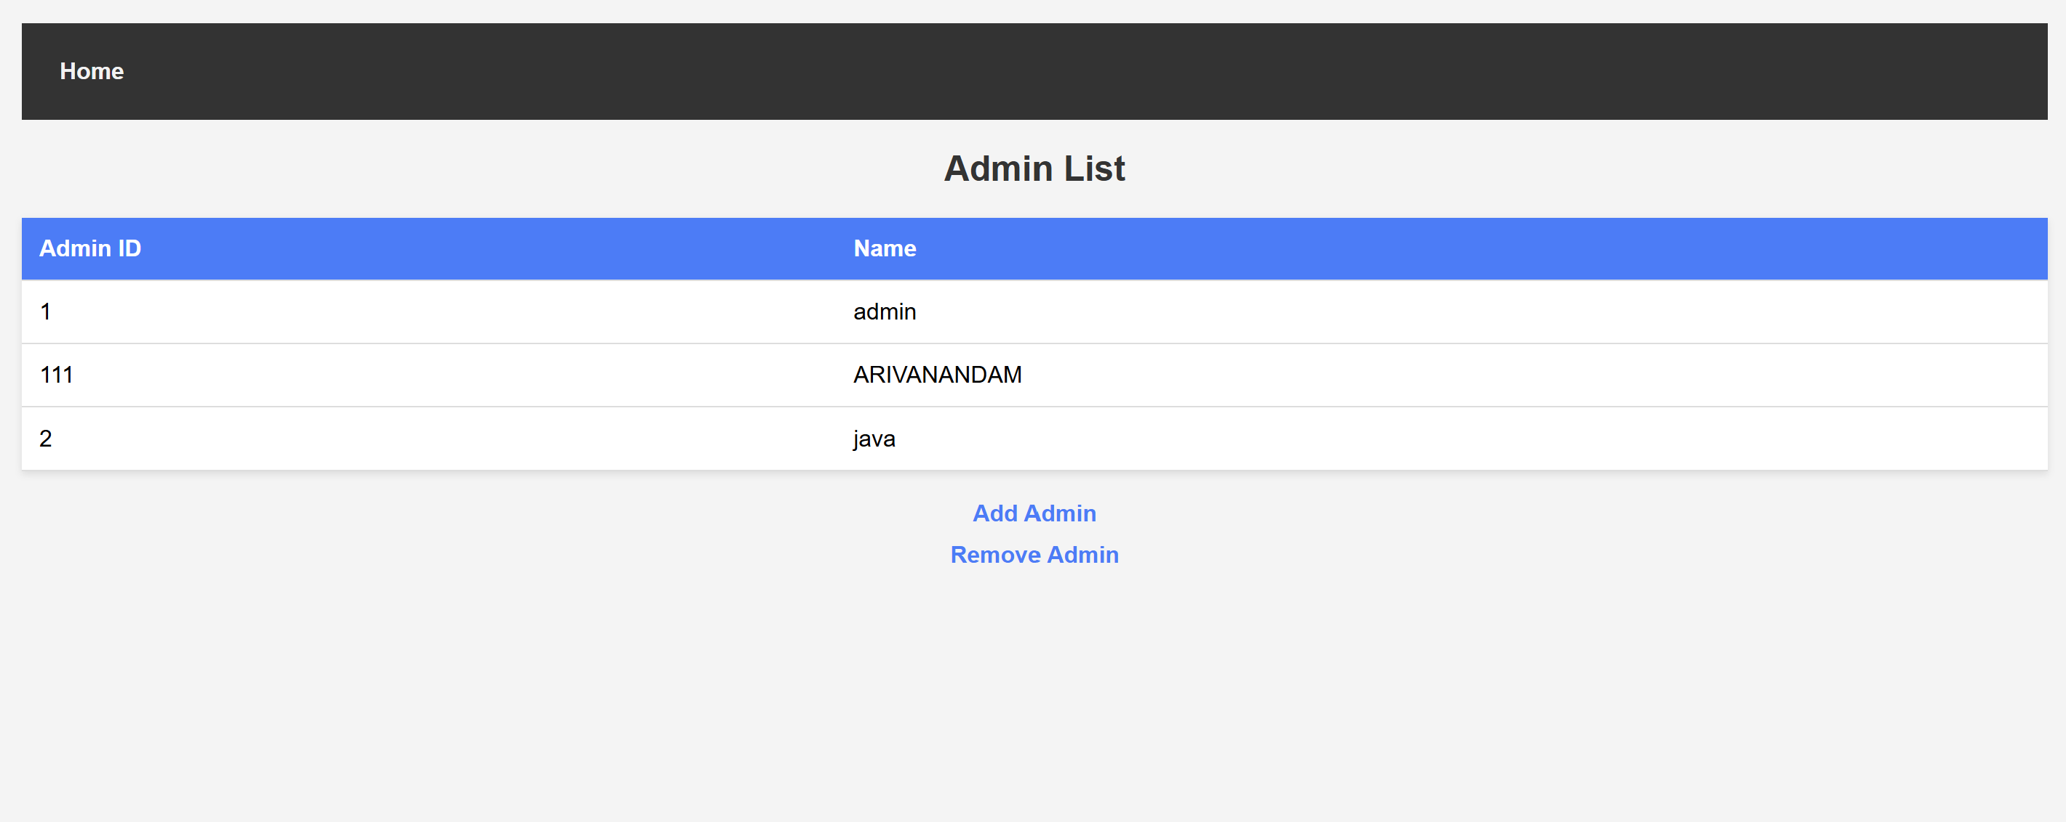

Change reflected in table admin

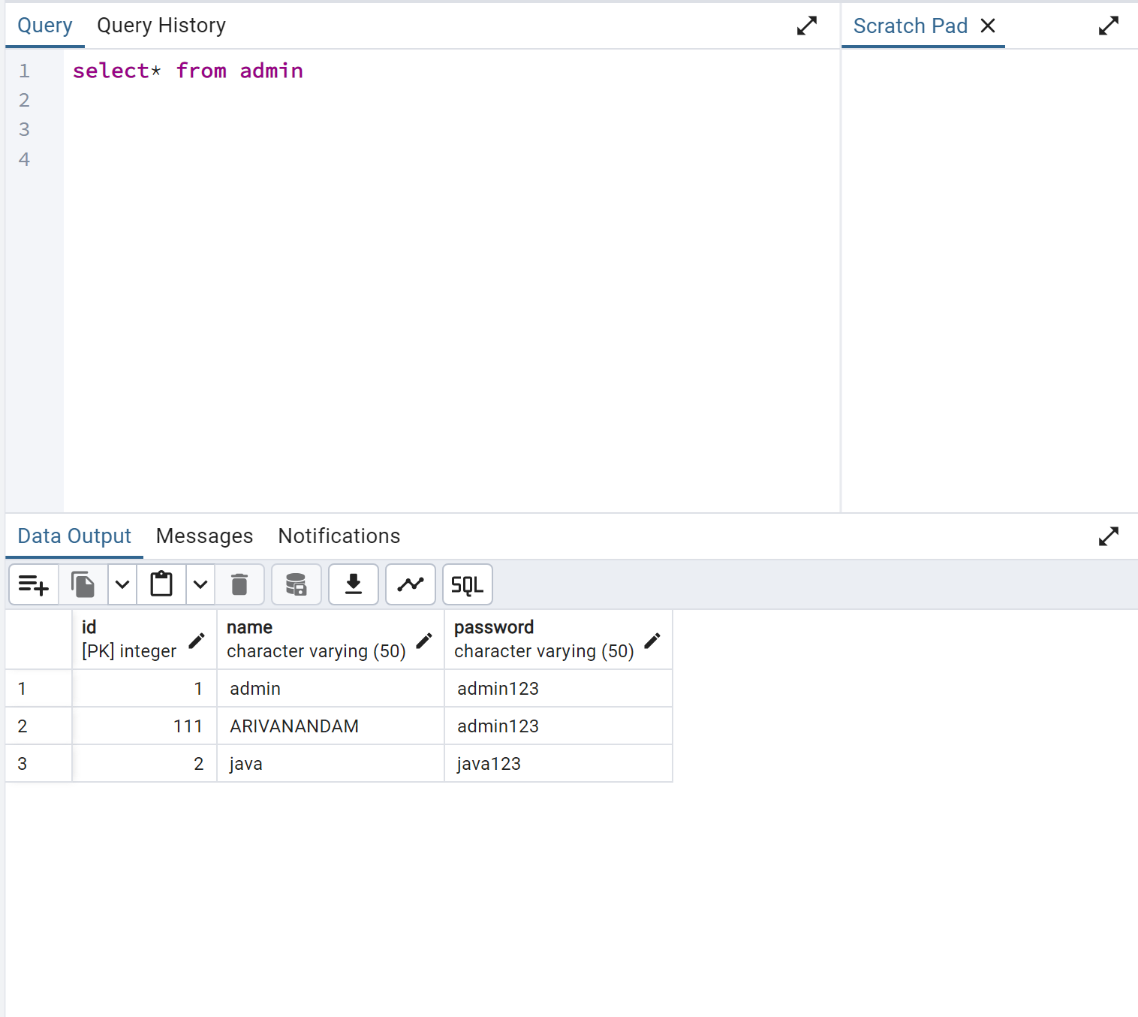

Logging in using newly created username and password

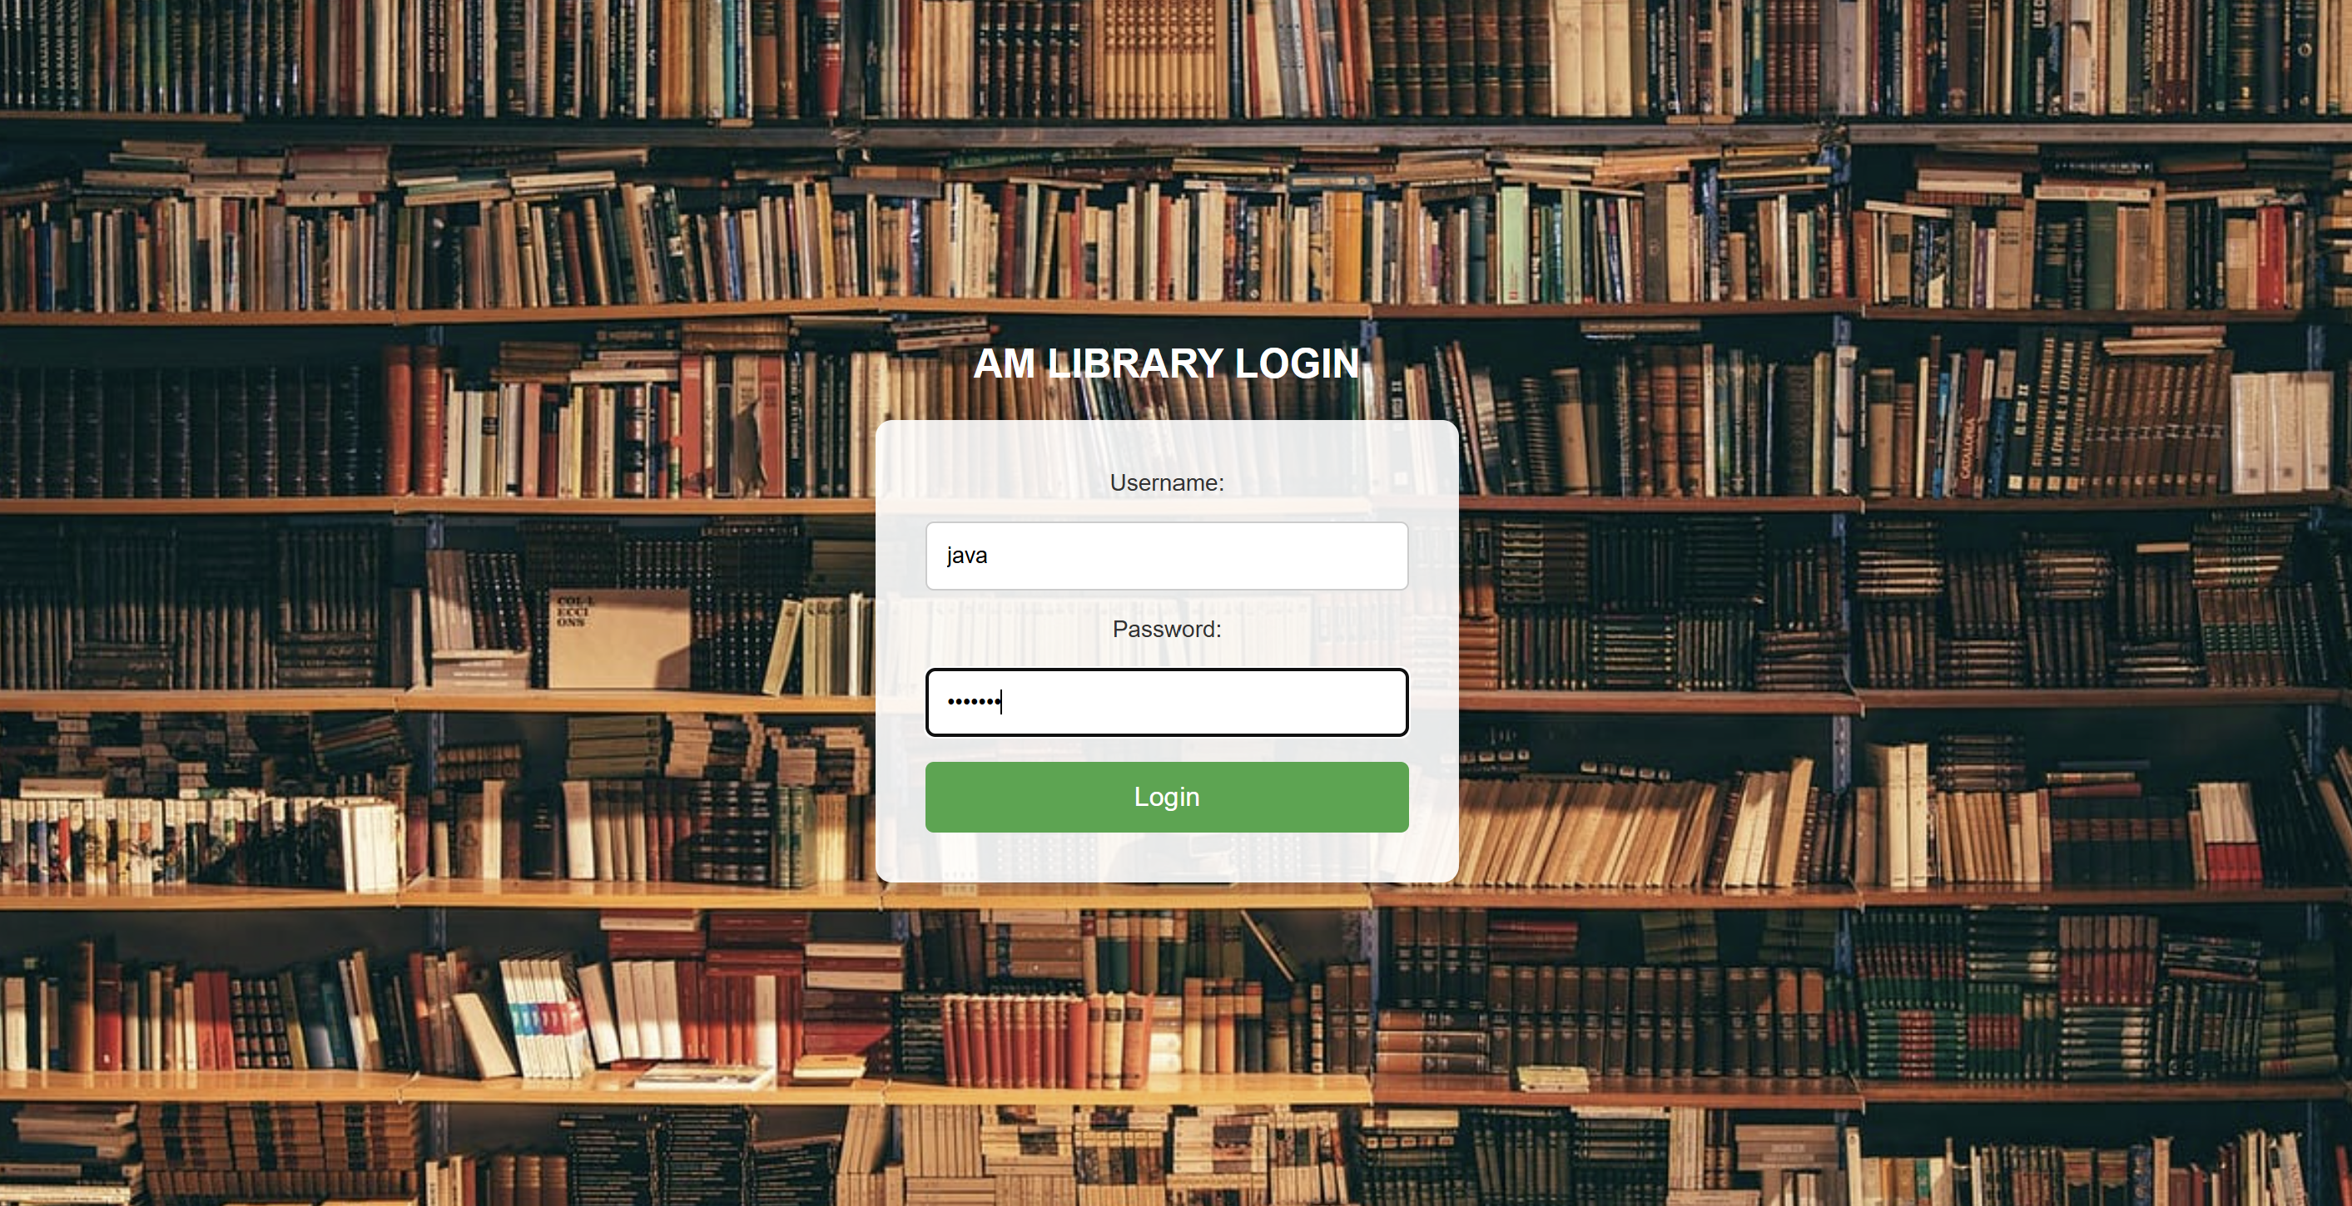

Login successful:



**removeStaff.jsp:** This page allows for the removal of existing admin accounts. It usually provides a selection method for choosing which admin to delete, and upon submission, the chosen admin is removed from the database.

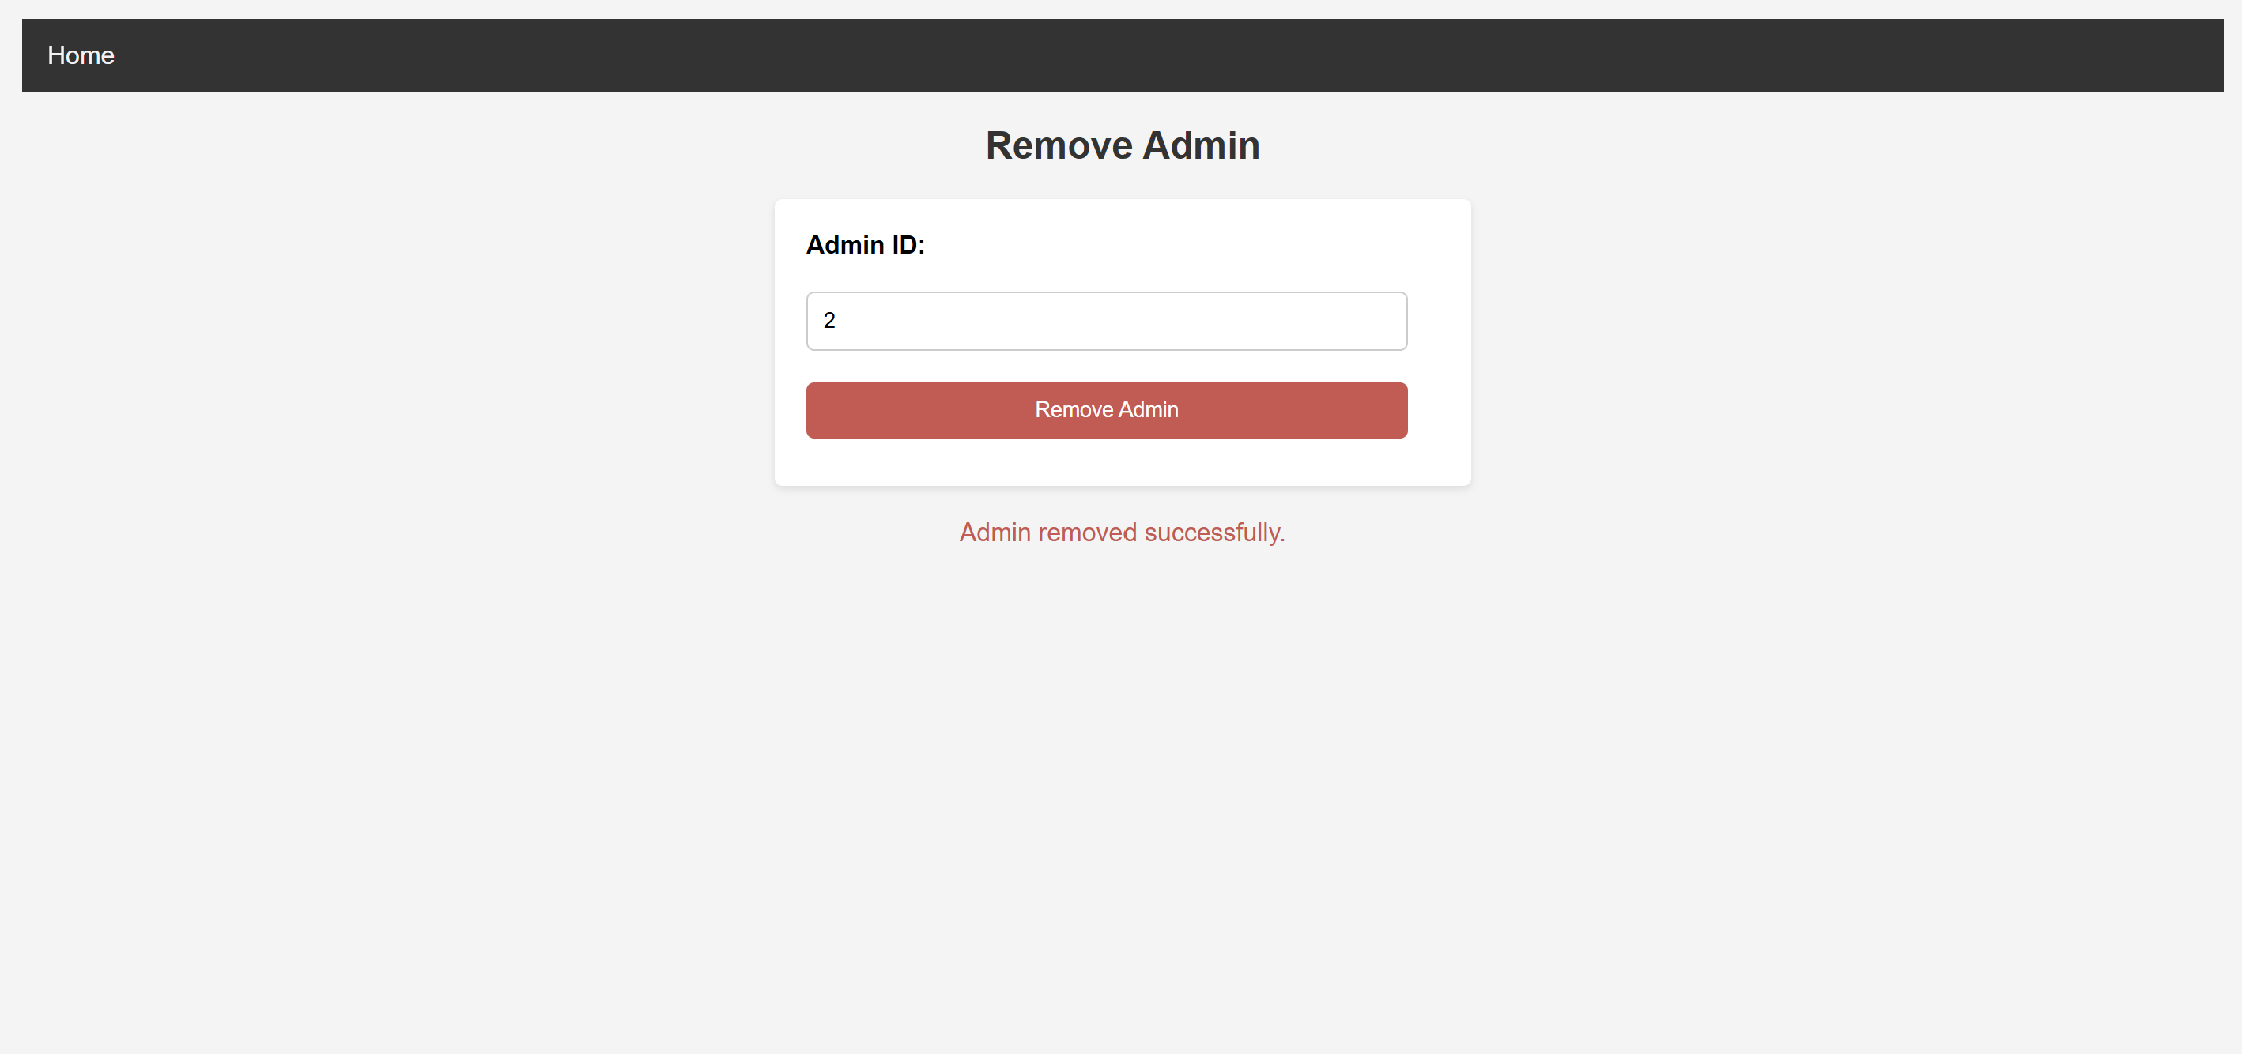

Change reflected in viewStaff.jsp

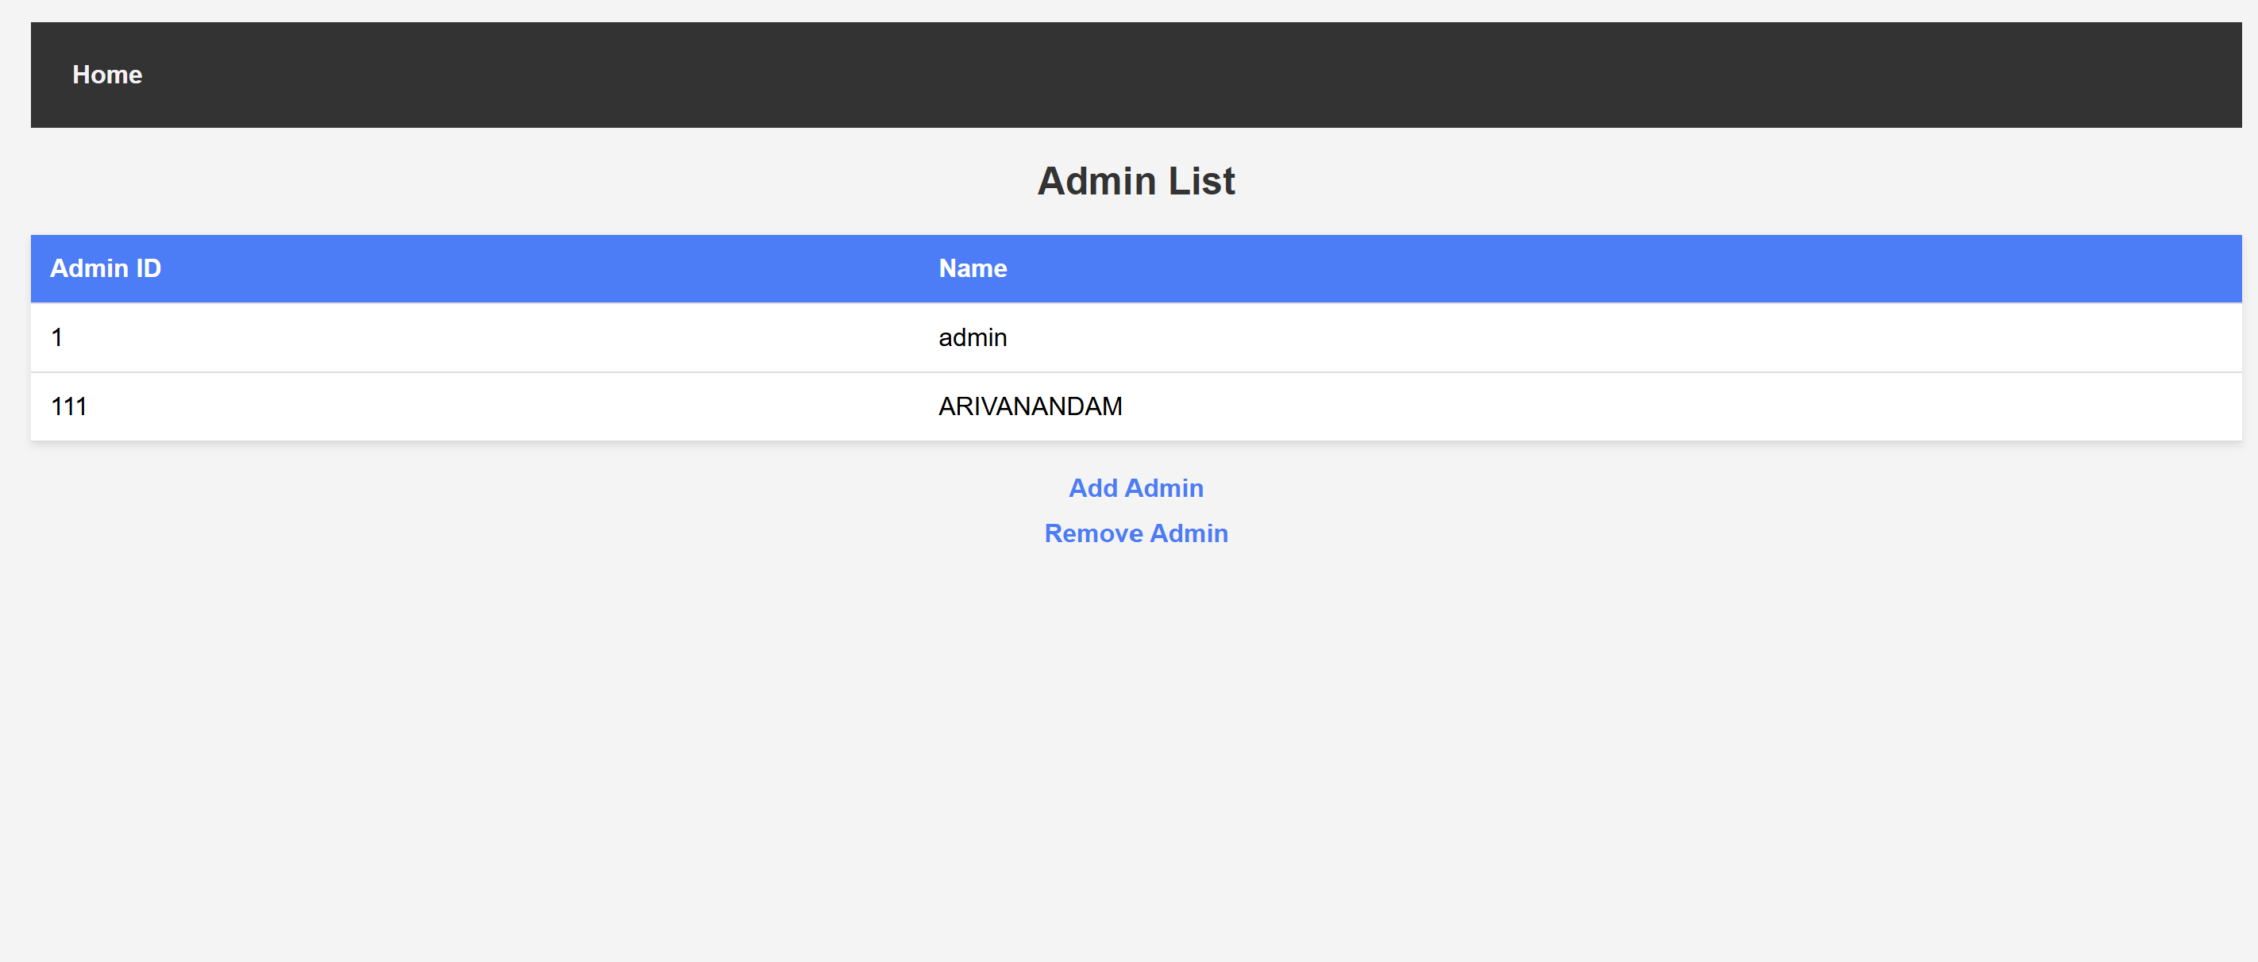

**ViewIssuedBooks.jsp:** This page shows a comprehensive list of books that have been issued to users. It includes details such as Issue ID, Book ID, Staff ID, Issue Date, and Return Date. If a book has not yet been returned, a message is displayed. The page also features a link to add new issued book records.

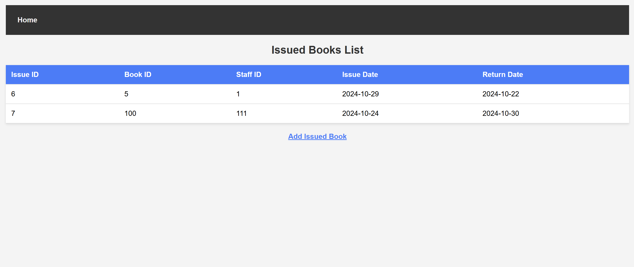

**addIssuedBook.jsp:** This page provides a form for staff to issue books to users. It includes input fields for Book ID, Staff ID, User ID, Issue Date, and Return Date. After filling out the form and submitting it, a new issued book record is created in the database.

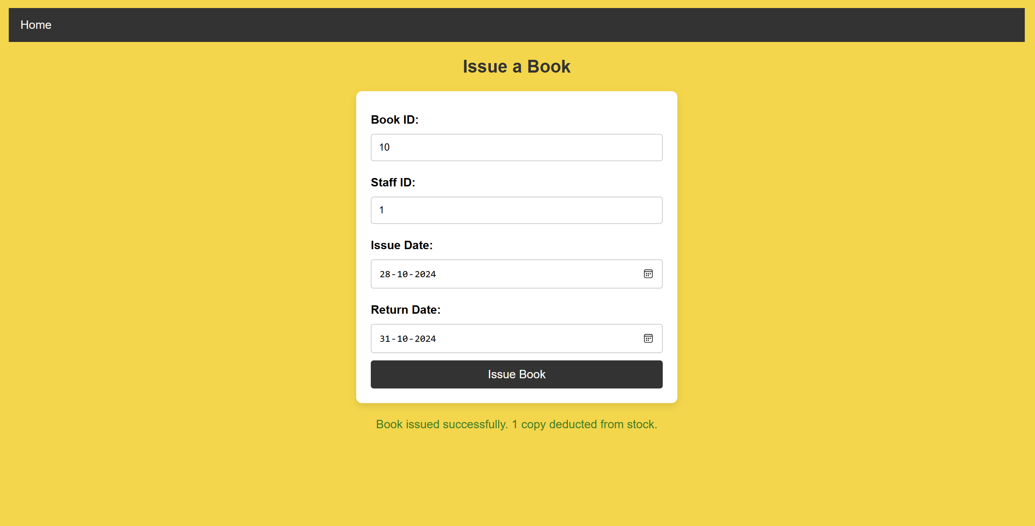

Change reflected in the table books:

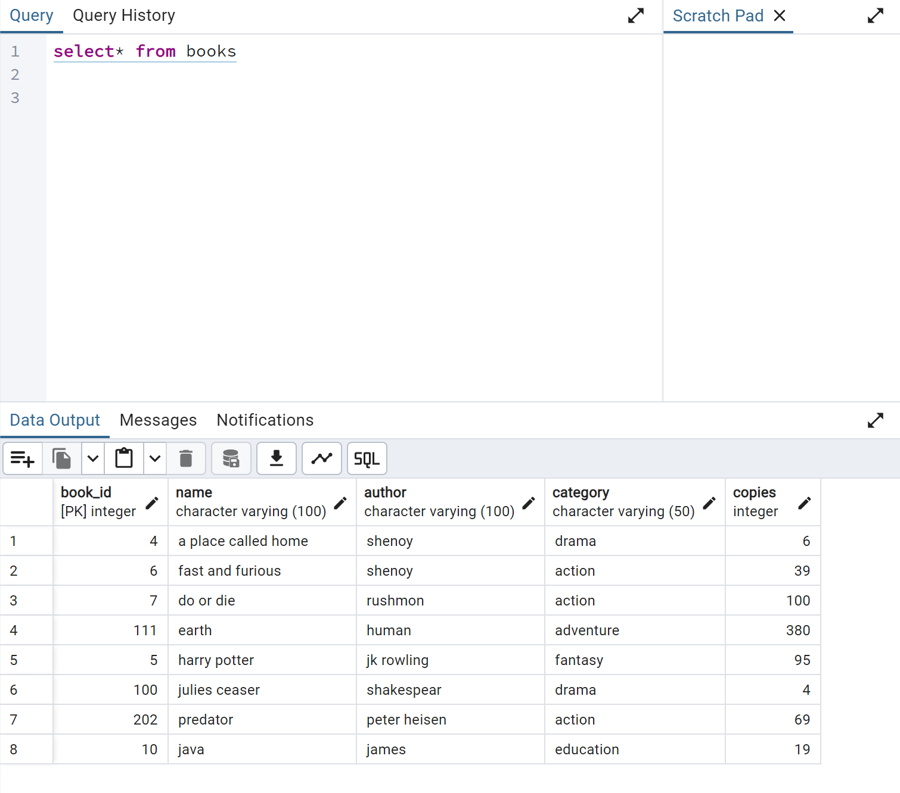

Change reflected in viewIssuedBooks.jsp

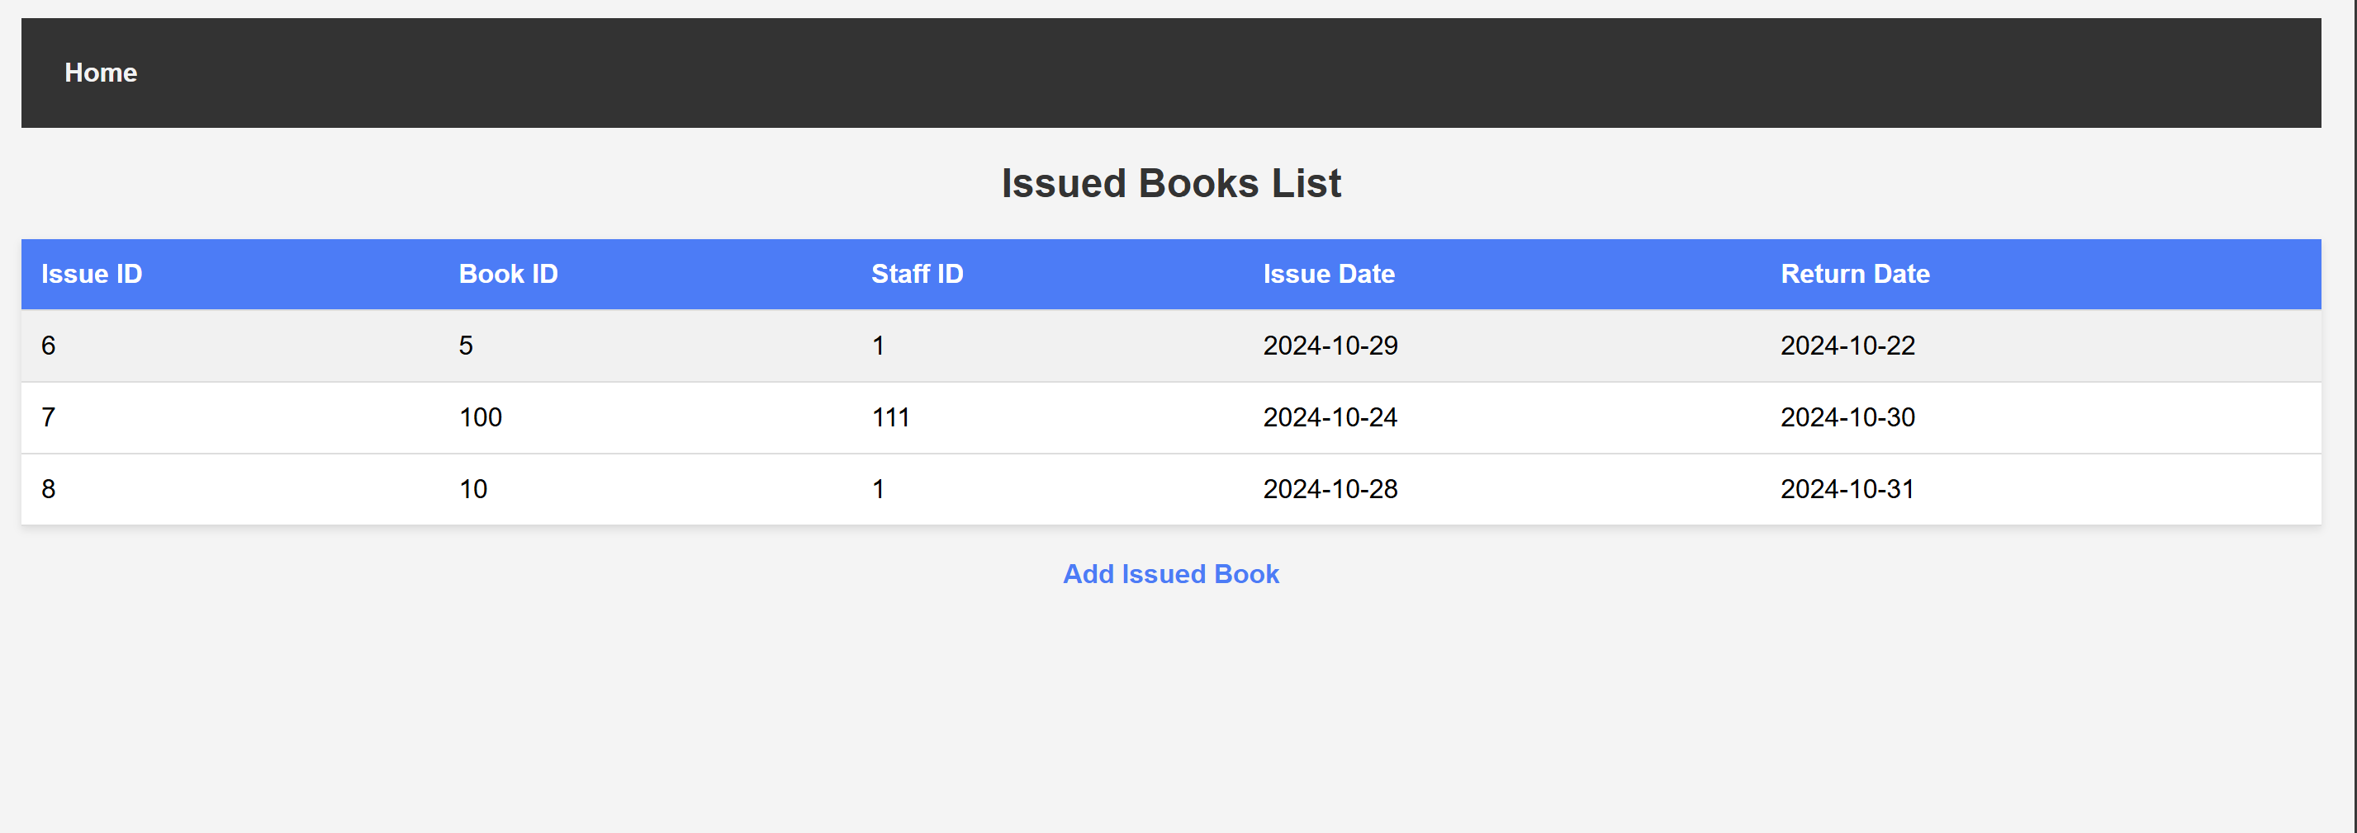

Change reflected in ViewBook.jsp

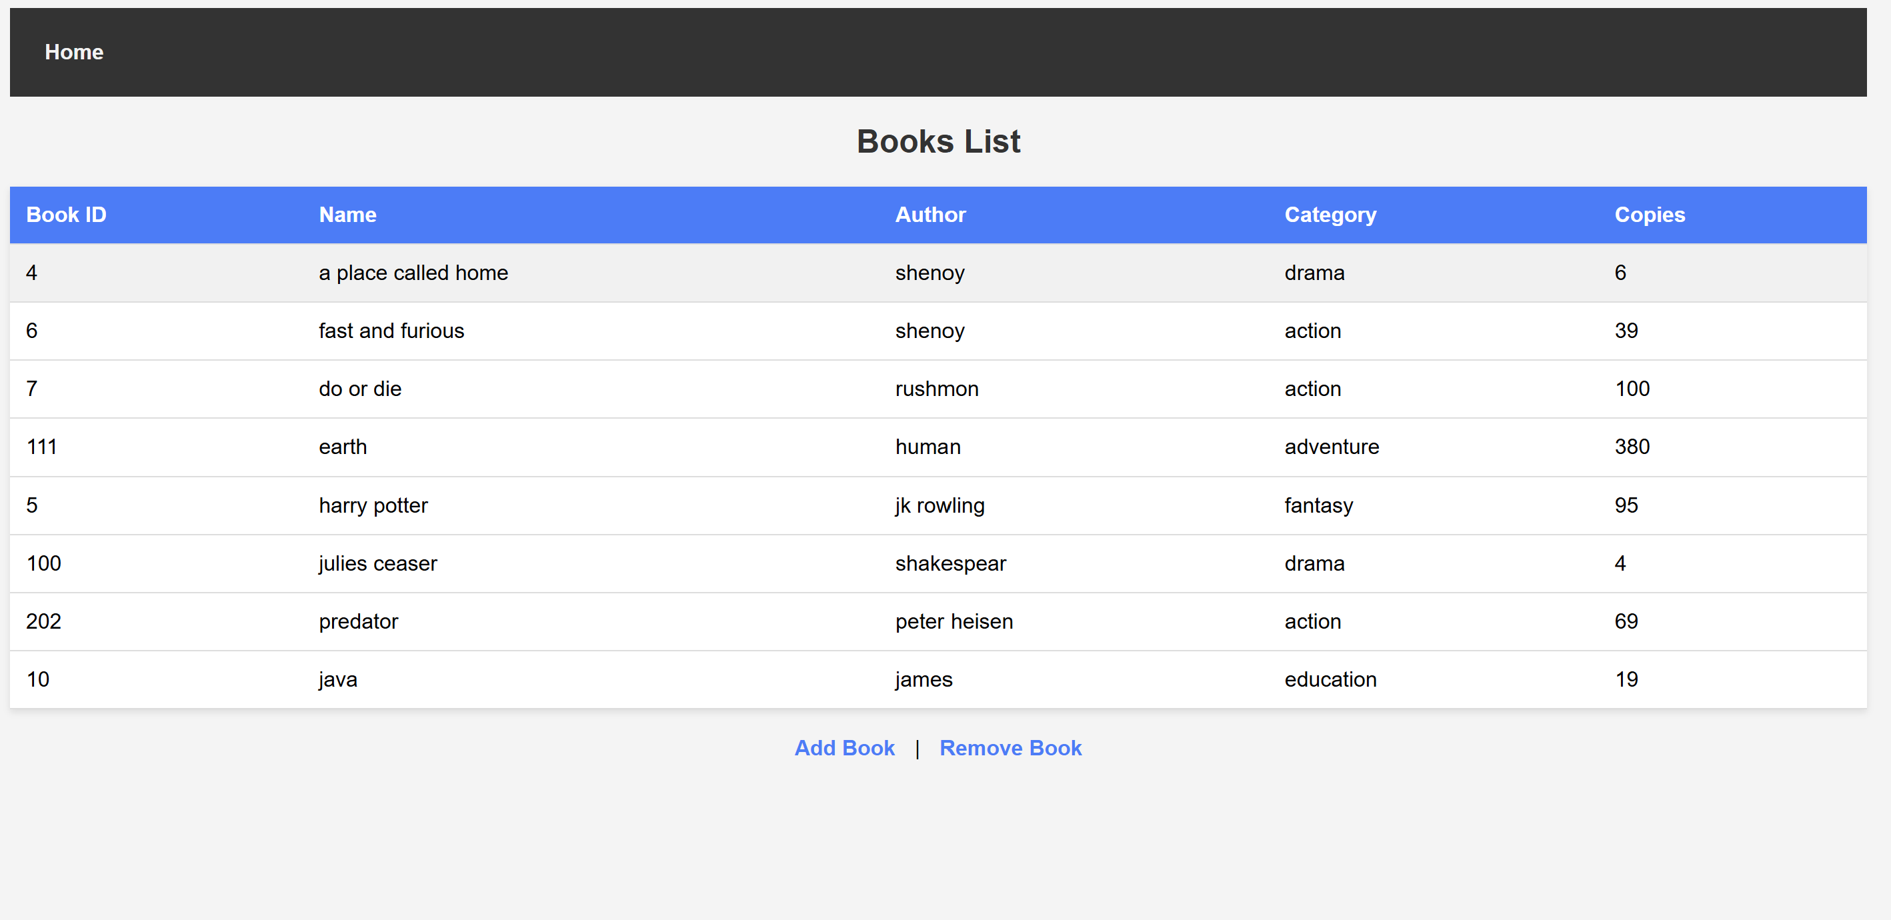

SOURCE CODES:

addBook.jsp:

<%@ include file="header.jsp" %>

<%@ page contentType="text/html;charset=UTF-8" language="java" %>

<%@ page import="java.sql.*" %>

<html>

<head>

<title>View Admins</title>

<style>

body {

font-family: Arial, sans-serif;

margin: 20px;

background-color: #f4f4f4;

}

h2 {

color: #333;

text-align: center;

}

table {

width: 100%;

border-collapse: collapse;

margin: 20px 0;

background-color: #fff;

box-shadow: 0 2px 5px rgba(0, 0, 0, 0.1);

}

th, td {

padding: 12px;

text-align: left;

border-bottom: 1px solid #ddd;

}

th {

background-color: #007bff;

color: white;

}

tr:hover {

background-color: #f1f1f1;

}

a {

text-decoration: none;

color: #007bff;

font-weight: bold;

margin: 10px;

display: block;

text-align: center;

}

a:hover {

text-decoration: underline;

}

</style>

</head>

<body>

<h2>Admin List</h2>

<table>

<tr>

<th>Admin ID</th>

<th>Name</th>

</tr>

<%

Connection conn = null;

Statement stmt = null;

ResultSet rs = null;

try {

Class.forName("org.postgresql.Driver");

conn = DriverManager.getConnection("jdbc:postgresql://localhost:5432/librarydb", "postgres", "Charchit@6639");

stmt = conn.createStatement();

String sql = "SELECT id, name FROM ADMIN";

rs = stmt.executeQuery(sql);

while (rs.next()) {

int adminId = rs.getInt("id");

String name = rs.getString("name");

%>

<tr>

<td><%= adminId %></td>

<td><%= name %></td>

</tr>

<%

}

} catch (Exception e) {

e.printStackTrace();

} finally {

if (rs != null) rs.close();

if (stmt != null) stmt.close();

if (conn != null) conn.close();

}

%>

</table>

<a href="addStaff.jsp">Add Admin</a>

<a href="removeStaff.jsp">Remove Admin</a>

</body>

</html>

**addIssuedBook.jsp:**

<%@ include file="header.jsp" %>

<%@ page import="java.sql.*" %>

<%@ page import="java.text.SimpleDateFormat" %>

<%@ page contentType="text/html;charset=UTF-8" language="java" %>

<html>

<head>

<title>Issue a Book</title>

<style>

body {

font-family: Arial, sans-serif;

background-color: #FFD500;

margin: 0;

padding: 20px;

}

h2 {

text-align: center;

color: #333;

}

form {

max-width: 400px;

margin: 0 auto;

padding: 20px;

background-color: white;

border-radius: 8px;

box-shadow: 0 4px 10px rgba(0, 0, 0, 0.1);

}

label {

font-weight: bold;

margin-top: 10px;

display: block;

}

input[type="text"],

input[type="date"] {

width: 100%;

padding: 10px;

margin: 10px 0;

border: 1px solid #ccc;

border-radius: 4px;

box-sizing: border-box;

}

input[type="submit"] {

background-color: #333;

color: white;

border: none;

padding: 10px;

border-radius: 4px;

cursor: pointer;

font-size: 16px;

width: 100%;

}

input[type="submit"]:hover {

background-color: #555;

}

.message {

text-align: center;

color: green;

margin-top: 20px;

}

.error {

text-align: center;

color: red;

margin-top: 20px;

}

</style>

</head>

<body>

<h2>Issue a Book</h2>

<form method="post" action="addIssuedBook.jsp">

<label for="bookId">Book ID:</label>

<input type="text" id="bookId" name="bookId" required>

<label for="staffId">Staff ID:</label>

<input type="text" id="staffId" name="staffId" required>

<label for="issueDate">Issue Date:</label>

<input type="date" id="issueDate" name="issueDate" required>

<label for="returnDate">Return Date:</label>

<input type="date" id="returnDate" name="returnDate">

<input type="submit" value="Issue Book">

</form>

<%

if (request.getParameter("bookId") != null && request.getParameter("staffId") != null) {

int bookId = Integer.parseInt(request.getParameter("bookId"));

int staffId = Integer.parseInt(request.getParameter("staffId"));

String issueDateStr = request.getParameter("issueDate");

String returnDateStr = request.getParameter("returnDate");

Connection conn = null;

PreparedStatement pstmt = null;

PreparedStatement updateStmt = null;

ResultSet rs = null;

try {

// Parse the string to java.sql.Date

SimpleDateFormat dateFormat = new SimpleDateFormat("yyyy-MM-dd");

java.sql.Date issueDate = new java.sql.Date(dateFormat.parse(issueDateStr).getTime());

java.sql.Date returnDate = null;

if (returnDateStr != null && !returnDateStr.isEmpty()) {

returnDate = new java.sql.Date(dateFormat.parse(returnDateStr).getTime());

}

Class.forName("org.postgresql.Driver");

conn = DriverManager.getConnection("jdbc:postgresql://localhost:5432/librarydb", "postgres", "Charchit@6639");

// Check if the book has available copies

String checkAvailabilitySql = "SELECT copies FROM books WHERE book_id = ?";

pstmt = conn.prepareStatement(checkAvailabilitySql);

pstmt.setInt(1, bookId);

rs = pstmt.executeQuery();

if (rs.next()) {

int availableCopies = rs.getInt("copies");

if (availableCopies > 0) {

// Proceed with the transaction

String insertSql = "INSERT INTO issued_books (book_id, staff_id, issue_date, return_date) VALUES (?, ?, ?, ?)";

pstmt = conn.prepareStatement(insertSql);

pstmt.setInt(1, bookId);

pstmt.setInt(2, staffId);

pstmt.setDate(3, issueDate);

if (returnDate != null) {

pstmt.setDate(4, returnDate);

} else {

pstmt.setNull(4, java.sql.Types.DATE);

}

pstmt.executeUpdate();

// Deduct one copy from the books table

String updateBookSql = "UPDATE books SET copies = copies - 1 WHERE book_id = ?";

updateStmt = conn.prepareStatement(updateBookSql);

updateStmt.setInt(1, bookId);

updateStmt.executeUpdate();

out.println("<div class='message'>Book issued successfully. 1 copy deducted from stock.</div>");

} else {

out.println("<div class='error'>No available copies of this book.</div>");

}

} else {

out.println("<div class='error'>Book not found.</div>");

}

} catch (SQLException e) {

out.println("<div class='error'>SQL Exception: " + e.getMessage() + "</div>");

e.printStackTrace();

} catch (ClassNotFoundException e) {

out.println("<div class='error'>JDBC Driver not found: " + e.getMessage() + "</div>");

e.printStackTrace();

} catch (Exception e) {

out.println("<div class='error'>Exception: " + e.getMessage() + "</div>");

e.printStackTrace();

} finally {

try {

if (rs != null) rs.close();

if (pstmt != null) pstmt.close();

if (updateStmt != null) updateStmt.close();

if (conn != null) conn.close();

} catch (SQLException e) {

e.printStackTrace();

}

}

}

%>

</body>

</html>

**addstaff.jsp:**

<%@ include file="header.jsp" %>

<%@ page import="java.sql.*" %>

<%@ page contentType="text/html;charset=UTF-8" language="java" %>

<html>

<head>

<title>Add Admin</title>

<style>

body {

font-family: Arial, sans-serif;

background-color: #FFD500;

margin: 0;

padding: 20px;

}

h2 {

text-align: center;

color: #333;

}

form {

max-width: 400px;

margin: 0 auto;

padding: 20px;

background-color: white;

border-radius: 8px;

box-shadow: 0 4px 10px rgba(0, 0, 0, 0.1);

}

label {

font-weight: bold;

margin-top: 10px;

display: block;

}

input[type="number"],

input[type="text"],

input[type="password"] {

width: 100%;

padding: 10px;

margin: 10px 0;

border: 1px solid #ccc;

border-radius: 4px;

box-sizing: border-box;

}

input[type="submit"] {

background-color: #333;

color: white;

border: none;

padding: 10px;

border-radius: 4px;

cursor: pointer;

font-size: 16px;

width: 100%;

}

input[type="submit"]:hover {

background-color: #555;

}

.message {

text-align: center;

color: green;

margin-top: 20px;

}

.error {

text-align: center;

color: red;

margin-top: 20px;

}

</style>

</head>

<body>

<h2>Add Admin</h2>

<form method="post" action="addStaff.jsp">

<label for="adminId">Admin ID:</label>

<input type="number" id="adminId" name="adminId" required>

<label for="name">Name:</label>

<input type="text" id="name" name="name" required>

<label for="password">Password:</label>

<input type="password" id="password" name="password" required>

<input type="submit" value="Add Admin">

</form>

<%

if (request.getParameter("adminId") != null) {

try {

// Parse adminId as an integer

int adminId = Integer.parseInt(request.getParameter("adminId"));

String name = request.getParameter("name");

String password = request.getParameter("password");

Connection conn = null;

PreparedStatement pstmt = null;

try {

Class.forName("org.postgresql.Driver");

conn = DriverManager.getConnection("jdbc:postgresql://localhost:5432/librarydb", "postgres", "Charchit@6639");

String sql = "INSERT INTO ADMIN (id, name, password) VALUES (?, ?, ?)";

pstmt = conn.prepareStatement(sql);

pstmt.setInt(1, adminId); // Set the adminId as integer

pstmt.setString(2, name);

pstmt.setString(3, password);

pstmt.executeUpdate();

out.println("<div class='message'>Admin added successfully.</div>");

} catch (SQLException e) {

out.println("<div class='error'>SQL Exception: " + e.getMessage() + "</div>");

} catch (ClassNotFoundException e) {

out.println("<div class='error'>JDBC Driver not found: " + e.getMessage() + "</div>");

} finally {

if (pstmt != null) pstmt.close();

if (conn != null) conn.close();

}

} catch (NumberFormatException e) {

out.println("<div class='error'>Invalid Admin ID format. Please enter a valid number.</div>");

}

}

%>

</body>

</html>

**header.jsp**

<%@ page contentType="text/html;charset=UTF-8" language="java" %>

<html>

<head>

<style>

.navbar {

background-color: #333;

overflow: hidden;

}

.navbar a {

float: left;

display: block;

color: #f2f2f2;

text-align: center;

padding: 14px 16px;

text-decoration: none;

}

.navbar a:hover {

background-color: #ddd;

color: black;

}

</style>

</head>

<body>

<div class="navbar">

<a href="redirect.jsp">Home</a>

<!-- Add more common links if needed -->

</div>

</body>

</html>

**index.html**

<!DOCTYPE html>

<html lang="en">

<head>

<meta charset="UTF-8">

<meta http-equiv="X-UA-Compatible" content="IE=edge">

<meta name="viewport" content="width=device-width, initial-scale=1.0">

<title> AM LIBRARY </title>

<style>

body {

font-family: Arial, sans-serif;

margin: 0;

padding: 0;

background-color: #FFD500; /* Background color */

position: relative;

height: 100vh;

}

header {

background-color: rgba(0, 0, 0, 0.7); /* Slight transparency */

color: white;

padding: 15px 0;

text-align: center;

position: relative;

}

header img {

opacity: 0.7; /* Reduced opacity of image */

width: 100%; /* Full screen width */

height: auto;

position: absolute;

top: 0;

left: 0;

z-index: -1; /* Set behind content */

}

nav {

background-color: #FFD500;

padding: 10px;

text-align: center;

}

nav a {

color: white;

padding: 14px 20px;

margin: 10px; /* Added margin to space out links */

text-decoration: none;

font-size: 18px;

display: inline-block;

}

nav a:hover {

background-color: #000000; /* Change hover color */

}

main {

padding: 20px;

text-align: center;

background-color: white; /* Changed background color to white */

}

footer {

background-color: rgba(0, 0, 0, 0.7);

color: white;

padding: 10px;

text-align: center;

position: fixed;

width: 100%;

bottom: 0;

}

img {

max-width: 100%; /* Make images responsive */

height: auto; /* Maintain aspect ratio */

}

.main-img {

opacity: 1;

}

.header-content {

display: flex; /* Use flexbox for alignment */

align-items: center; /* Center items vertically */

justify-content: center; /* Center items horizontally */

}

.header-content img {

margin-right: 15px; /* Space between logo and text */

}

</style>

</head>

<body>

<header>

<div class="header-content">

<img src="logo.png" alt="AM Library Logo" style="width: 100px; height: auto;"> <!-- Adjust size as needed -->

<h1 style="margin: 0;">AM LIBRARY</h1> <!-- Remove margin for better alignment -->

</div>

<img src="images/books-2602030_1280.jpg" alt="Library">

</header>

<nav>

<a href="viewBooks.jsp">View Books</a>

<a href="addBook.jsp">Add Book</a>

<a href="removeBook.jsp">Remove Book</a>

<a href="viewStaff.jsp">View Staff</a>

<a href="addStaff.jsp">Add Staff</a>

<a href="removeStaff.jsp">Remove Staff</a>

<a href="viewIssuedBooks.jsp">View Issued Books</a>

<a href="addIssuedBook.jsp">Issue Book</a>

</nav>

<main>

<h2>Welcome to AM Library Management System</h2>

<p>Please use the navigation above to manage the library database.</p>

<img src="images/welcome.jpg" alt="Welcome" class="main-img" style="width: 30%; height: auto;">

</main>

<footer>

<p>Library Management System @Coimbatore</p>

</footer>

</body>

</html>

**login.jsp**

<%@ page language="java" contentType="text/html; charset=UTF-8" pageEncoding="UTF-8"%>

<%@ page import="java.sql.*" %>

<html lang="en">

<head>

<title>Login Page</title>

<style>

body {

font-family: Arial, sans-serif;

background-image: url('images/login.jpg'); /* Correct path to the image */

background-size: cover; /* Cover the entire viewport */

background-position: center; /* Center the background image */

margin: 0;

padding: 0;

display: flex;

justify-content: center;

align-items: center;

height: 100vh; /* Full height of the viewport */

}

.container {

text-align: center; /* Center the header text */

}

h2 {

color: white; /* White color for header */

margin-bottom: 20px;

}

form {

background-color: rgba(255, 255, 255, 0.9); /* White with some transparency */

border-radius: 10px; /* Rounded corners */

box-shadow: 0 4px 15px rgba(0, 0, 0, 0.2); /* Subtle shadow */

padding: 30px; /* Padding inside the form */

max-width: 350px; /* Slightly wider form */

width: 100%; /* Full width */

box-sizing: border-box; /* Include padding and border in width */

margin: 0 auto; /* Center form horizontally */

}

input[type="text"],

input[type="password"] {

width: 100%; /* Full width input */

padding: 12px; /* Padding for inputs */

margin: 15px 0; /* Margin for spacing */

border: 1px solid #ccc; /* Light gray border */

border-radius: 5px; /* Rounded corners for inputs */

box-sizing: border-box; /* Include padding and border in total width */

}

input[type="submit"] {

background-color: #28a745; /* Green background for submit button */

color: white; /* White text for button */

border: none; /* No border */

padding: 12px; /* Padding for button */

cursor: pointer; /* Pointer cursor on hover */

border-radius: 5px; /* Rounded corners for button */

width: 100%; /* Full width button */

font-size: 16px; /* Larger font for submit button */

transition: background-color 0.3s; /* Smooth transition for background */

}

input[type="submit"]:hover {

background-color: #218838; /* Darker green on hover */

}

.error {

color: red; /* Red color for error messages */

text-align: center; /* Center the error message */

margin-top: 10px;

}

label {

font-size: 14px;

color: #333; /* Dark color for labels */

}

</style>

</head>

<body>

<div class="container">

<h2>AM LIBRARY LOGIN</h2>

<form method="post" action="">

<label for="username">Username:</label>

<input type="text" name="username" required>

<label for="password">Password:</label>

<input type="password" name="password" required>

<input type="submit" value="Login">

</form>

</div>

<%

if(request.getParameter("username") != null && request.getParameter("password") != null) {

String username = request.getParameter("username");

String password = request.getParameter("password");

Connection conn = null;

PreparedStatement pstmt = null;

ResultSet rs = null;

try {

Class.forName("org.postgresql.Driver");

conn = DriverManager.getConnection("jdbc:postgresql://localhost:5432/librarydb", "postgres", "Charchit@6639");

String sql = "SELECT * FROM ADMIN WHERE NAME=? AND PASSWORD=?";

pstmt = conn.prepareStatement(sql);

pstmt.setString(1, username);

pstmt.setString(2, password);

rs = pstmt.executeQuery();

if(rs.next()) {

response.sendRedirect("index.html");

} else {

out.println("<p class='error'>Invalid username or password.</p>");

}

} catch (Exception e) {

e.printStackTrace();

} finally {

if(rs != null) rs.close();

if(pstmt != null) pstmt.close();

if(conn != null) conn.close();

}

}

%>

</body>

</html>

**redirect.jsp**

<%--

Views should be stored under the WEB-INF folder so that

they are not accessible except through controller process.

This JSP is here to provide a redirect to the dispatcher

servlet but should be the only JSP outside of WEB-INF.

--%>

<%@page contentType="text/html" pageEncoding="UTF-8"%>

<% response.sendRedirect("index.html"); %>

**removeBook.jsp**

<%@ include file="header.jsp" %>

<%@ page import="java.sql.*" %>

<%@ page contentType="text/html;charset=UTF-8" language="java" %>

<html>

<head>

<title>Remove Book</title>

<style>

body {

font-family: Arial, sans-serif;

margin: 20px;

background-color: #f4f4f4;

}

h2 {

color: #333;

}

form {

background: #fff;

padding: 20px;

border-radius: 5px;

box-shadow: 0 2px 5px rgba(0, 0, 0, 0.1);

max-width: 400px;

margin: auto;

}

input[type="text"], input[type="number"], input[type="submit"] {

width: calc(100% - 20px);

padding: 10px;

margin: 10px 0;

border: 1px solid #ccc;

border-radius: 5px;

}

input[type="submit"] {

background-color: #5cb85c;

color: white;

border: none;

cursor: pointer;

}

input[type="submit"]:hover {

background-color: #4cae4c;

}

.message {

text-align: center;

margin-top: 20px;

color: #d9534f; /* red color for error messages */

}

</style>

</head>

<body>

<h2>Remove Book</h2>

<form method="post" action="removeBook.jsp">

<label for="bookId">Book ID:</label>

<input type="text" id="bookId" name="bookId" required placeholder="Enter Book ID">

<label for="copiesToRemove">Number of Copies to Remove:</label>

<input type="number" id="copiesToRemove" name="copiesToRemove" required min="1" placeholder="Enter number of copies to remove">

<input type="submit" value="Remove Book">

</form>

<%

String bookIdParam = request.getParameter("bookId");

String copiesToRemoveParam = request.getParameter("copiesToRemove");

if (bookIdParam != null && copiesToRemoveParam != null) {

int bookId = Integer.parseInt(bookIdParam);

int copiesToRemove = Integer.parseInt(copiesToRemoveParam);

Connection conn = null;

PreparedStatement pstmtSelect = null;

PreparedStatement pstmtUpdate = null;

PreparedStatement pstmtDelete = null;

ResultSet rs = null;

try {

// Load PostgreSQL driver and connect to database

Class.forName("org.postgresql.Driver");

conn = DriverManager.getConnection("jdbc:postgresql://localhost:5432/librarydb", "postgres", "Charchit@6639");

// Query to get the current number of copies

String sqlSelect = "SELECT COPIES FROM BOOKS WHERE BOOK_ID = ?";

pstmtSelect = conn.prepareStatement(sqlSelect);

pstmtSelect.setInt(1, bookId);

rs = pstmtSelect.executeQuery();

if (rs.next()) {

int currentCopies = rs.getInt("COPIES");

if (copiesToRemove <= currentCopies) {

if (copiesToRemove < currentCopies) {

// Reduce the number of copies by the specified amount

String sqlUpdate = "UPDATE BOOKS SET COPIES = COPIES - ? WHERE BOOK_ID = ?";

pstmtUpdate = conn.prepareStatement(sqlUpdate);

pstmtUpdate.setInt(1, copiesToRemove);

pstmtUpdate.setInt(2, bookId);

int updatedRows = pstmtUpdate.executeUpdate();

if (updatedRows > 0) {

out.println("<div class='message'>" + copiesToRemove + " copies of the book were removed successfully. Remaining copies: " + (currentCopies - copiesToRemove) + ".</div>");

} else {

out.println("<div class='message'>Failed to update book copies.</div>");

}

} else if (copiesToRemove == currentCopies) {

// If the number of copies to remove is equal to the current number, delete the book

String sqlDelete = "DELETE FROM BOOKS WHERE BOOK_ID = ?";

pstmtDelete = conn.prepareStatement(sqlDelete);

pstmtDelete.setInt(1, bookId);

int deletedRows = pstmtDelete.executeUpdate();

if (deletedRows > 0) {

out.println("<div class='message'>Book removed successfully as all copies were removed.</div>");

} else {

out.println("<div class='message'>Failed to remove the book.</div>");

}

}

} else {

out.println("<div class='message'>You cannot remove more copies than available. Available copies: " + currentCopies + ".</div>");

}

} else {

out.println("<div class='message'>Book not found with the given ID.</div>");

}

} catch (SQLException e) {

out.println("<div class='message'>SQL Exception: " + e.getMessage() + "</div>");

e.printStackTrace();

} catch (ClassNotFoundException e) {

out.println("<div class='message'>Class Not Found Exception: " + e.getMessage() + "</div>");

e.printStackTrace();

} finally {

// Close resources properly

try {

if (rs != null) rs.close();

if (pstmtSelect != null) pstmtSelect.close();

if (pstmtUpdate != null) pstmtUpdate.close();

if (pstmtDelete != null) pstmtDelete.close();

if (conn != null) conn.close();

} catch (SQLException e) {

e.printStackTrace();

}

}

}

%>

</body>

</html>

**removeStaff.jsp**

<%@ include file="header.jsp" %>

<%@ page import="java.sql.*" %>

<%@ page contentType="text/html;charset=UTF-8" language="java" %>

<html>

<head>

<title>Remove Staff</title>

<style>

body {

font-family: Arial, sans-serif;

margin: 20px;

background-color: #f4f4f4;

}

h2 {

color: #333;

text-align: center;

}

form {

background: #fff;

padding: 20px;

border-radius: 5px;

box-shadow: 0 2px 5px rgba(0, 0, 0, 0.1);

max-width: 400px;

margin: auto;

}

label {

display: block;

margin-bottom: 10px;

font-weight: bold;

}

input[type="text"], input[type="submit"] {

width: calc(100% - 20px);

padding: 10px;

margin: 10px 0;

border: 1px solid #ccc;

border-radius: 5px;

}

input[type="submit"] {

background-color: #d9534f;

color: white;

border: none;

cursor: pointer;

}

input[type="submit"]:hover {

background-color: #c9302c;

}

.message {

text-align: center;

margin-top: 20px;

color: #d9534f;

}

</style>

</head>

<body>

<h2>Remove Admin</h2>

<form method="post" action="removeStaff.jsp">

<label for="adminId">Admin ID:</label>

<input type="text" id="adminId" name="adminId" required placeholder="Enter Admin ID">

<input type="submit" value="Remove Admin">

</form>

<%

if (request.getParameter("adminId") != null) {

int adminId = Integer.parseInt(request.getParameter("adminId"));

Connection conn = null;

PreparedStatement pstmt = null;

try {

Class.forName("org.postgresql.Driver");

conn = DriverManager.getConnection("jdbc:postgresql://localhost:5432/librarydb", "postgres", "Charchit@6639");

String sql = "DELETE FROM ADMIN WHERE id = ?";

pstmt = conn.prepareStatement(sql);

pstmt.setInt(1, adminId);

int rowsAffected = pstmt.executeUpdate();

if (rowsAffected > 0) {

out.println("<div class='message'>Admin removed successfully.</div>");

} else {

out.println("<div class='message'>No admin found with the given ID.</div>");

}

} catch (SQLException e) {

out.println("<div class='message'>SQL Exception: " + e.getMessage() + "</div>");

} catch (ClassNotFoundException e) {

out.println("<div class='message'>Class Not Found Exception: " + e.getMessage() + "</div>");

} finally {

try {

if (pstmt != null) pstmt.close();

if (conn != null) conn.close();

} catch (SQLException e) {

e.printStackTrace();

}

}

}

%>

</body>

</html>

**viewBooks.jsp**

<%@ include file="header.jsp" %>

<%@ page contentType="text/html;charset=UTF-8" language="java" %>

<%@ page import="java.sql.*" %>

<html>

<head>

<title>View Books</title>

<style>

body {

font-family: Arial, sans-serif;

margin: 20px;

background-color: #f4f4f4;

}

h2 {

color: #333;

text-align: center;

}

table {

width: 100%;

border-collapse: collapse;

margin: 20px 0;

background-color: #fff;

box-shadow: 0 2px 5px rgba(0, 0, 0, 0.1);

}

th, td {

padding: 12px;

text-align: left;

border-bottom: 1px solid #ddd;

}

th {

background-color: #007bff;

color: white;

}

tr:hover {

background-color: #f1f1f1;

}

a {

text-decoration: none;

color: #007bff;

font-weight: bold;

margin: 10px;

}

a:hover {

text-decoration: underline;

}

.links {

text-align: center;

margin-top: 20px;

}

</style>

</head>

<body>

<h2>Books List</h2>

<table>

<tr>

<th>Book ID</th>

<th>Name</th>

<th>Author</th>

<th>Category</th>

<th>Copies</th>

</tr>

<%

Connection conn = null;

Statement stmt = null;

ResultSet rs = null;

try {

Class.forName("org.postgresql.Driver");

conn = DriverManager.getConnection("jdbc:postgresql://localhost:5432/librarydb", "postgres", "Charchit@6639");

stmt = conn.createStatement();

String sql = "SELECT * FROM BOOKS";

rs = stmt.executeQuery(sql);

while (rs.next()) {

int bookId = rs.getInt("BOOK_ID");

String name = rs.getString("NAME");

String author = rs.getString("AUTHOR");

String category = rs.getString("CATEGORY");

int copies = rs.getInt("COPIES");

%>

<tr>

<td><%= bookId %></td>

<td><%= name %></td>

<td><%= author %></td>

<td><%= category %></td>

<td><%= copies %></td>

</tr>

<%

}

} catch (Exception e) {

e.printStackTrace();

} finally {

if (rs != null) rs.close();

if (stmt != null) stmt.close();

if (conn != null) conn.close();

}

%>

</table>

<div class="links">

<a href="addBook.jsp">Add Book</a> | <a href="removeBook.jsp">Remove Book</a>

</div>

</body>

</html>

**ViewIssuedBooks.jsp**

<%@ include file="header.jsp" %>

<%@ page contentType="text/html;charset=UTF-8" language="java" %>

<%@ page import="java.sql.*" %>

<html>

<head>

<title>View Issued Books</title>

<style>

body {

font-family: Arial, sans-serif;

margin: 20px;

background-color: #f4f4f4;

}

h2 {

color: #333;

text-align: center;

}

table {

width: 100%;

border-collapse: collapse;

margin: 20px 0;

background-color: #fff;

box-shadow: 0 2px 5px rgba(0, 0, 0, 0.1);

}

th, td {

padding: 12px;

text-align: left;

border-bottom: 1px solid #ddd;

}

th {

background-color: #007bff;

color: white;

}

tr:hover {

background-color: #f1f1f1;

}

a {

text-decoration: none;

color: #007bff;

font-weight: bold;

margin: 10px;

display: block;

text-align: center;

}

a:hover {

text-decoration: underline;

}

</style>

</head>

<body>

<h2>Issued Books List</h2>

<table>

<tr>

<th>Issue ID</th>

<th>Book ID</th>

<th>Staff ID</th>

<th>Issue Date</th>

<th>Return Date</th>

</tr>

<%

Connection conn = null;

Statement stmt = null;

ResultSet rs = null;

try {

Class.forName("org.postgresql.Driver");

conn = DriverManager.getConnection("jdbc:postgresql://localhost:5432/librarydb", "postgres", "Charchit@6639");

stmt = conn.createStatement();

String sql = "SELECT * FROM issued_books";

rs = stmt.executeQuery(sql);

while (rs.next()) {

int issueId = rs.getInt("issue_id");

int bookId = rs.getInt("book_id");

int staffId = rs.getInt("staff_id");

Date issueDate = rs.getDate("issue_date");

Date returnDate = rs.getDate("return_date");

%>

<tr>

<td><%= issueId %></td>

<td><%= bookId %></td>

<td><%= staffId %></td>

<td><%= issueDate %></td>

<td><%= returnDate != null ? returnDate : "Not returned yet" %></td>

</tr>

<%

}

} catch (Exception e) {

e.printStackTrace();

} finally {

if (rs != null) rs.close();

if (stmt != null) stmt.close();

if (conn != null) conn.close();

}

%>

</table>

<a href="addIssuedBook.jsp">Add Issued Book</a>

</body>

</html>

**ViewStaff.jsp**

<%@ include file="header.jsp" %>

<%@ page contentType="text/html;charset=UTF-8" language="java" %>

<%@ page import="java.sql.*" %>

<html>

<head>

<title>View Admins</title>

<style>

body {

font-family: Arial, sans-serif;

margin: 20px;

background-color: #f4f4f4;

}

h2 {

color: #333;

text-align: center;

}

table {

width: 100%;

border-collapse: collapse;

margin: 20px 0;

background-color: #fff;

box-shadow: 0 2px 5px rgba(0, 0, 0, 0.1);

}

th, td {

padding: 12px;

text-align: left;

border-bottom: 1px solid #ddd;

}

th {

background-color: #007bff;

color: white;

}

tr:hover {

background-color: #f1f1f1;

}

a {

text-decoration: none;

color: #007bff;

font-weight: bold;

margin: 10px;

display: block;

text-align: center;

}

a:hover {

text-decoration: underline;

}

</style>

</head>

<body>

<h2>Admin List</h2>

<table>

<tr>

<th>Admin ID</th>

<th>Name</th>

</tr>

<%

Connection conn = null;

Statement stmt = null;

ResultSet rs = null;

try {

Class.forName("org.postgresql.Driver");

conn = DriverManager.getConnection("jdbc:postgresql://localhost:5432/librarydb", "postgres", "Charchit@6639");

stmt = conn.createStatement();

String sql = "SELECT id, name FROM ADMIN";

rs = stmt.executeQuery(sql);

while (rs.next()) {

int adminId = rs.getInt("id");

String name = rs.getString("name");

%>

<tr>

<td><%= adminId %></td>

<td><%= name %></td>

</tr>

<%

}

} catch (Exception e) {

e.printStackTrace();

} finally {

if (rs != null) rs.close();

if (stmt != null) stmt.close();

if (conn != null) conn.close();

}

%>

</table>

<a href="addStaff.jsp">Add Admin</a>

<a href="removeStaff.jsp">Remove Admin</a>

</body>

</html>